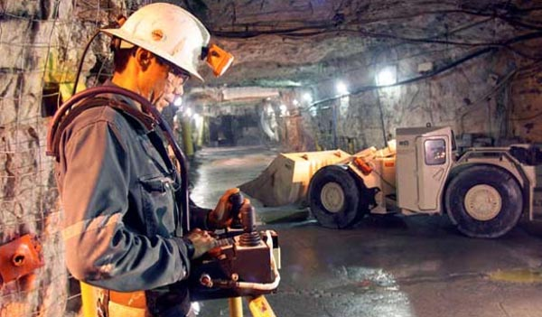 **Mining Safety Management System**By: Piyush Chandra, Dimitar Kirilov, Abhishek Ranjan, Ajinkya Upasani

Table of Contents

List of Figures 7

List of Tables 8

I Project Description 9

1 Project Overview 9

2 The Purpose of the Project 9

2a The User Business or Background of the Project Effort 9

2b Goals of the Project 9

2c Measurement 10

3 The Scope of the Work 10

3a The Current Situation 10

3b The Context of the Work 12

3c Work Partitioning 12

3d Competing Products 14

o Altair 4X Mining Multigas detector – It detects LEL, oxygen, carbon monoxide and hydrogen sulphide. 14

o Altairs 5X Multigas detector – It can measure up to 6 gases simultaneously and can detect in LEL and volume percentage range, oxygen, carbon monoxide, carbon dioxide, carbon dioxide, hydrogen sulfide, sulfur dioxide, ammonia, chlorine, VOCs, and many others depending on sensor configuration. 14

4 The Scope of the Product 15

4a Scenario Diagram(s) 15

4b Product Scenario List 16

4c Individual Product Scenarios 17

5 Stakeholders 19

5a The Client 19

5b The Customer 19

5c Hands-On Users of the Product 19

5d Priorities Assigned to Users 20

5e User Participation 21

5f Maintenance Users and Service Technicians 22

5g Other Stakeholders 22

6 Mandated Constraints 23

6a Solution Constraints 23

6b Implementation Environment of the Current System 25

6c Partner or Collaborative Applications 25

6d Off-the-Shelf Software 25

6e Anticipated Workplace Environment 26

6f Schedule Constraints 26

6g Budget Constraints 26

7 Naming Conventions and Definitions 27

7a Definitions of Key Terms 27

7b UML and Other Notation Used in This Document 27

7c Data Dictionary for Any Included Models 27

8 Relevant Facts and Assumptions 28

8a Facts 28

8b Assumptions 28

II Requirements 29

9 Product Use Cases 29

9a Use Case Diagrams 29

9b Product Use Case List 30

9c Individual Product Use Cases 31

10 Functional Requirements 39

11 Data Requirements 49

12 Performance Requirements 50

12a Speed and Latency Requirements 50

12b Precision or Accuracy Requirements 51

12c Capacity Requirements 51

13 Dependability Requirements 51

13a Reliability Requirements 51

13b Availability Requirements 52

13c Robustness or Fault-Tolerance Requirements 52

13d Safety-Critical Requirements 52

14 Maintainability and Supportability Requirements 53

14a Maintenance Requirements 53

14b Supportability Requirements 53

14c Adaptability Requirements 54

14d Scalability or Extensibility Requirements 54

14e Longevity Requirements 54

15 Security Requirements 55

15a Access Requirements 55

15b Integrity Requirements 55

15c Privacy Requirements 55

15d Audit Requirements 56

15e Immunity Requirements 56

16 Usability and Humanity Requirements 56

16a Ease of Use Requirements 56

16b Personalization and Internationalization Requirements 57

16c Learning Requirements 58

16d Understandability and Politeness Requirements 58

16e Accessibility Requirements 58

16f User Documentation Requirements 59

16g Training Requirements 59

17 Look and Feel Requirements 59

17a Appearance Requirements 59

17b Style Requirements 60

18 Operational and Environmental Requirements 60

18a Expected Physical Environment 60

18b Requirements for Interfacing with Adjacent Systems 60

18c Productization Requirements 61

18d Release Requirements 62

19 Cultural and Political Requirements 62

19a Cultural Requirements 62

19b Political Requirements 62

20 Legal Requirements 63

20a Compliance Requirements 63

20b Standards Requirements 63

III Design 64

21 System Design 64

21a Design goals 64

22 Current Software Architecture 64

23 Proposed Software Architecture 64

23a Overview 64

23b Class Diagrams 64

23c Dynamic Model 66

23d Subsystem Decomposition 67

23e Hardware / software mapping 67

23f Data Dictionary 68

23g Persistent Data management 68

23h Access control and security 68

23i Global software control 68

23j Boundary conditions 69

24 Subsystem services 69

25 User Interface 69

26 Object Design 71

26a Object Design trade-offs 71

26b Interface Documentation guidelines 71

26c Packages 71

26d Class Interfaces 71

IV Test Plans 71

27 Features to be tested / not to be tested 72

28 Pass/Fail Criteria 72

29 Approach 72

30 Suspension and resumption 73

31 Testing materials ( hardware / software requirements ) 73

32 Test cases 73

V Project Issues 79

33 Open Issues 79

34 Off-the-Shelf Solutions 79

34a Ready-Made Products 79

34b Reusable Components 80

34c Products That Can Be Copied 80

35 New Problems 81

35a Effects on the Current Environment 81

35b Effects on the Installed Systems 82

35c Potential User Problems 82

35d Limitations in the Anticipated Implementation Environment That May Inhibit the New Product 82

35e Follow-Up Problems 82

36 Tasks 83

36a Project Planning 83

36b Planning of the Development Phases 83

37 Migration to the New Product 84

37a Requirements for Migration to the New Product 84

37b Data That Has to Be Modified or Translated for the New System 84

38 Risks 84

39 Costs 85

40 Waiting Room 86

41 Ideas for Solutions 86

42 Project Retrospective 87

VI Glossary 87

VII References / Bibliography 87

VIII Index 88

### ****List of Figures****

Figure 1 12

Figure 2 15

Figure 3 16

Figure 4 25

Figure 5 30

Figure 6 50

Figure 7 65

Figure 8 66

Figure 9 66

Figure 10 67

Figure 11 67

Figure 12 71

Figure 13 83

### ****List of Tables****

N/A – All Tables are shown as figures.

# 

# Project Description

## Project Overview

The proposed product “Mining Safety Management System” is a system developed with the need for the protection of the mine workers in the mines. Data would be collected in real-time from the mining sites and be analyzed by the system to maintain a risk-free environment in the mines.

## The Purpose of the Project

### The User Business or Background of the Project Effort

Mining is one of the oldest occupations in the world dating back as long as 40,000 years. Over the years, the targeted substances and the technology to get them has changed drastically, however, the desire to extract resources from the Earth has remained the same.

In modern days, man has tried to get his hands on the variety of material from the Earth’s crust like metals, ores, stones, gems, and gems. We have ventured into as deep as 3 miles below the Earth in the form of mines to get these natural resources. Although technology has proven to be a huge contributing factor in the creation of these deep mines, we haven’t been able to substitute the work of a human that is required in these mines. Hundreds and thousands of miners go down into these mines every day in search of these resources.

However, as it turns out, mining is one of the most dangerous occupations currently out there. The risks that a miner faces while working are immense. A miner’s life is at stake inside these mines due to lack of ventilation, gas ignition, extreme noise levels, cave-ins, heat and dust exposures, and many more.

Hence, our product tries to maintain a safe environment within the mines on various fronts using real-time data that would be perceived by sensors installed in the mines and studied upon for emergency situations. The data collected from one mine would not be reserved to that particular mine, but would be pooled on a higher level to study and extrapolate the data towards similar mines all around the area.

### Goals of the Project

The goal of our project is to build a system which will improve the safety of miners and give them a confidence while working in mines. It will be an integration of several components:

* Ground Level/Surface Vibration Detection
* Toxic/ Flammable Gas Detection
* Equipment Failure Detection
* GPS System for the Miners and Sensors
* Heart Rate Monitor

Mining accidents are amongst one the most common in the workplace industry with an average fatality rate of over 25 people per year just in the United States according to the United States Department of Labor’s Mine Safety and Health Administration. Many die every year due to the ignorance of proper safety standards and lack of quality systems which can easily prevent such accidents from occurring. Such horrific accidents are shown below:

* Upper Big Branch Mining Disaster: In West Virginia, United States in 2010, 29 miners out of 31 who were present at the site were killed. The deaths could have been avoided if the ventilation system would have worked properly.
* In Soma, Manisa, Turkey, in the year 2014 an underground fire inside the mine killed 301 people and injured several others. It started with an explosion and later caught fire and most of the people died because of carbon monoxide poisoning.

These are instances of mining accidents where many people die because of lack of safety systems. The goal of our software is to make their work environment more secure and reliable.

### Measurement

To measure the success of this software, observations on the number of reported accidents due to mining would have to be made and determine whether the number has gone down. If there is a significant drop in the number of fatalities and people developing long term diseases, then this software has successfully done its job in helping the users.

## The Scope of the Work

### The Current Situation

Back in the old days, the miners would learn to recognize the risks associated within the mines by themselves as technology back then couldn’t afford for sensors and quick communication devices. The new miners were sent down with the experienced ones who would talk about their past experiences and all the tricks of the trade associated with the safety measures involved in the mining. These miners would check the stability of the roofs of the mines unground by manual effort, a practice which was unsafe, to say the least.

However, the boom in technology has seen a fair development in technology associated with the safety measures of the miners involved. The lay of the land is scanned before a miner would start to work looking for instability in the mines that would cause a cave-in. As basic as it may sound, the GPS sensors and communication devices afforded to each miner have maintained the security in a sense that they won’t get lost in the mines. Many miners in the olden days have been found to be lost in the deep mines as they weren’t able to find their way back to the exits as the mines were fairy complicated to walk through due to the lack of lighting measures back in those days.

The safety measures as we know don’t stop at the just studying the lay of the land at the beginning of the process, as safety in these environments is a process which demands real-time study of the mines. Toxic gases like methane which are very likely to incite explosions in the mines need to be analyzed. Many of the mines counter this problem of methane gas in the mine by spreading Calcium Hydroxide (Limestone dust) in the mines. Also, water is spread on the rocks to cool them down. Many of the other safety issues are addressed at the site like checking of the quality of the equipment. The study of the vibrations in the ground at the time of mining using vibration sensing equipment which use sensors like a ‘geophone’ to sense the change energy in the surrounding atmosphere of these devices.

The quality of the current equipment is checked thoroughly as a rustic or an old tool could generate more dust at the time when the equipment is used. This dust that is produced at the mines could cause respiratory diseases to the miners. Sometimes, this dust can also be carcinogenic. The safety measures in the current system related to these problems can range from relocation of miners to safer places in the mines to evacuation from the mines; ventilation and filtration of the dangerous atmosphere; use of robots in place of miners in very delicate areas of these mines. Many regulations have been placed by the governments to ensure the safety at these mining zones. Regular checks done by the government-appointed safety inspectors make sure that the safety regulations are being followed at these mining zones.

### The Context of the Work

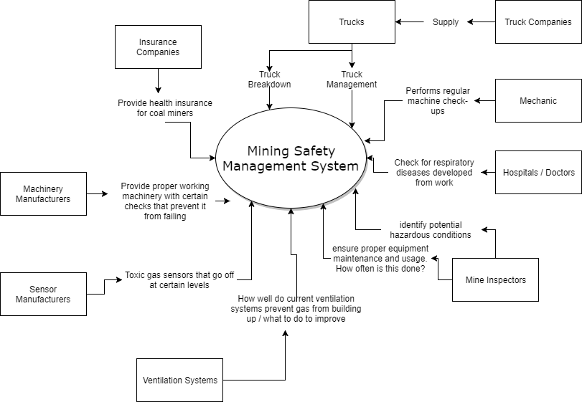

Figure 1

### Work Partitioning

|  |  |  |  |
| --- | --- | --- | --- |
| Sr. No | Event Name | Input and Output | Summary |
| 1. | Reading Gas volume level from Mines | Data obtained from Gas Sensors(**in**) | Reading from sensors installed in mines to capture volume level of Gases such as Methane, Carbon Monoxide is fed to information panel in the system on Real time basis. |
| 2. | Reading data from the systems installed in mines for vibration level. | Data obtained from Vibration Sensors(**in**) | Reading from the installed Geo Sensors for capturing vibration in Ground and Mine structure is captured by Information panel in Real time. |
| 3. | Reading Data from pressure sensors mounted on heavy equipment. | Data from Pressure Sensors(**in)** | Reading from Pressure sensors is fed to Information Panel. |
| 4. | Retrieval and capture of Maintenance Record. | Maintenance Record Data(**in**) | Information Panel captures and is fed maintenance record of the Equipment record. |
| 5. | Data movement from Information Panel to Data Analyzing System. | Data from Information Panel(**out**)  Data to Analyzing System(**in**) | Information Panel Feeds Useful/Valid Data to Analyzing System |
| 6. | Extraction of Information and its manipulation. | Interpretable Data Pattern(**out)** | Analyzing System will extract useful Information from Data and will manipulate it to match the preexisting Patterns. |
| 7. | Interpretation of manipulated Data. | Identification of fault/discrepancy from normal activity(**out**) | Analyzing system will identify fault/discrepancy from normal pattern and will alert the specific personnel for the same through trigger to Alarm System. |
| 8. | Alert for workers. | Alert sent out to worker(**out**)  Alert sent out to Site in charge(**out**) | In case System Identifies breach in toxic level of Gases will alert worker to keep off from the underground Mines.  Site in charge are asked to increase ventilation of Mines to dissipate the impact. |
| 9. | Alert to Ground Site Manager | Alert sent out to Ground Site- in charge(**out)** | In case there is breach with respect to vibration level in Ground/ Structure, Alert is released for the in-charge team to clear off the ground of any workers and take remedy action to bring vibration level back to Normal. |
| 10. | Alert to Mining Equipment in Charge. | Alert sent out to Mining Equipment in charge(**out)** | In case of any fault identified by Analyzing system based on the pattern drawn from the data fed to system by mounted stress and pressure sensors on Equipment, also taking into consideration it’s past Maintenance Record.  Equipment should be kept out of operation and sent out for maintenance in such a case |

### Competing Products

There are products in the market which measure ground level/surface vibrations, flammable or toxic gases and equipment failures, but none of them work together as a system to detect all the three. Let us look at some of the products:

* **MSA** – MSA is a safety company which creates safety products for workers protection.  It has created over thousands of safety products. One of the types of product it has created for mining safety is multigas detector. For example:

## Altair 4X Mining Multigas detector – It detects LEL, oxygen, carbon monoxide and hydrogen sulphide.

## Altairs 5X Multigas detector – It can measure up to 6 gases simultaneously and can detect in LEL and volume percentage range, oxygen, carbon monoxide, carbon dioxide, carbon dioxide, hydrogen sulfide, sulfur dioxide, ammonia, chlorine, VOCs, and many others depending on sensor configuration.

* **Komatsu –** Komatsu is a Japanese company and is second after US company Caterpillar in production of construction equipment. Recently it is working on a diagnostic project where it realizes prediction of unexpected failures using equipment’s sensor signals emitted in field of mining. This is the solution provided in collaboration with US based Predictronics and ISID and is called Intelligent Maintenance.
* **Instantel** – It is a global leader in with best-in-class vibration, noise and air overpressure equipment for quarries, mining, construction, civil, geotechnical and other applications. Some of its products used in mining are:
  + - Micromate: Monitoring unit with 4 available channels: three channels for recording vibration on three planes and one channel for air overpressure or noise data.
    - Triaxial Smart Geo: Records ground vibration in three planes: transverse, vertical and longitudinal. Does not have to be leveled when installed.
* **SKF Copperhead** - It is used for detection of process faults that may cause damage and       affect operation of system. The SKF Copperhead concept uses a specially developed vibration and temperature sensor permanently mounted on the vibrating screen. The sensor is designed to operate in harsh environments and is linked to either a periodic or continuous monitoring system.
* **Emerson Products** - Emerson produces a list of products which can be used for detecting a lot of toxic gases as well as sense combustibles. Some of the products like Millennium series can detect methane and other poisonous gases.

## The Scope of the Product

### Scenario Diagram(s)

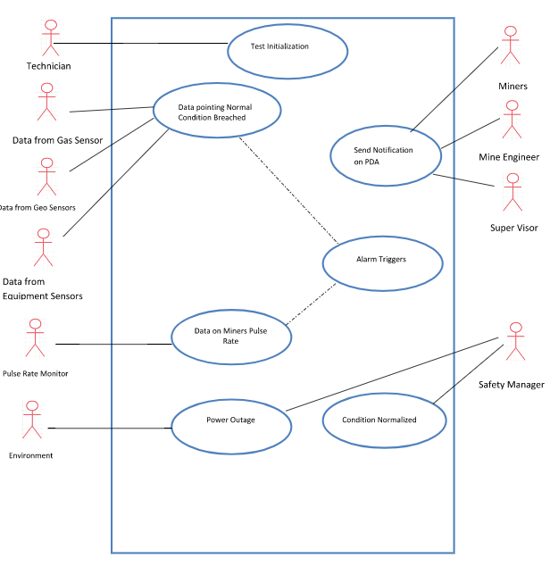

Figure 2

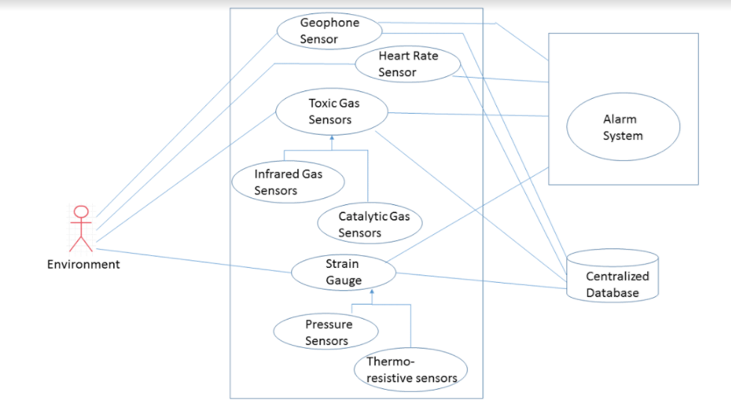

Figure 3

### Product Scenario List

|  |  |  |
| --- | --- | --- |
| **ID:** | **Name:** | **Actors:** |
| 1 | Avoiding High Methane Gas Levels | Environment, Mine Worker, Mine Safety Supervisor |
| 2 | Preventing a Fatality | Mine Worker, Mine Safety Supervisor, Environment |
| 3 | Report Generation | Environment |
| 4 | Equipment Tension | Environment, Equipment, Mine Worker |
| 5 | Ground Vibration Sensor | Environment |
| 6 | Pulse Rate Sensor | Environment, Mine Safety Supervisor |

### Individual Product Scenarios

**Scenario 1 (Avoiding High Methane Gas Levels):**

Carl is working as a mine safety supervisor and is currently sitting at his desk keenly monitoring all the sensors around the mine which are meant to prevent accidents from occurring. He notices that in a particular area the sensor readings for methane gas in the environment have started to rise and the system has automatically activated ventilation. After several minutes, Carl notices that despite the ventilation, the methane gas is still rising, although at a slower rate and approaching dangerous levels. He decides to alert the workers before the methane reaches a threshold and triggers the alarm on the workers' Safety Devices. Carl looks at the GPS map of the mine shown on his screen which displays the locations of all the workers as dots and selects the ones in range of the dangerous levels of methane. Once Carl has selected every worker, he prompts to select the "Contact" button on his screen which contacts him with the Safety Devices which the workers are wearing on them and proceeds to alert them of the methane gas. The workers eagerly evacuate and proceed work somewhere else until the methane gas has cleared up.

**Scenario 2 (Preventing a Fatality):**

Jack is working as a mine worker alone and is currently drilling to place explosives in the rock which is to be blown up to reveal resources. However, Jack doesn't realize that there is a support beam in range of his explosives. When he blows up the rock, a cave in is caused and Jack gets buried. Luckily, he somehow survives, but is badly injured and has no way of calling for help as his arms are trapped under, so he starts panicking.

It's Nick's shift to work as a mine safety supervisor today and he has been monitoring all the sensor's readings for a while. Suddenly, the system alerts of an abnormally high heart rate reading (caused by Jack's panic). Nick quickly reacts and attempts to contact Jack to assess the situation. Nick selects Jack's Safety Device on the mine's GPS map, selects the "Contact" option and asks Jack if everything is alright. After not getting a response for several seconds, Nick takes action and contacts the closest workers to Jack's GPS location for them to check up on him. When news arrives that Jack is stuck under a cave in and his condition seems to be worsening, Nick calls an ambulance which arrives shortly and takes Jack to the hospital. Luckily, the medics got to Jack in time and he was rescued.

**Scenario 3 (Equipment Tension)**

A mining group has started underground coal mining and it is using few old equipment’s in this mine. Out of the several products they are using, one of the product is caterpillar roof support system. This roof support system has become a bit old and right now it is holding a seam which is very heavy and the tension has increased tremendously. Now a lot of miners are working inside the mine. Mike is a data analyst who is monitoring the different data and graphs produced by our system. One of the data shows rise in tension of roof support equipment. He immediately raises an alarm and evacuate all the employees. After consulting the domain expert, Saul, the team gets one more roof support system and now both roof support system will be holding the heavy roof. After using this instrument, it will go for a maintenance and few of its parts may be changed if required. Also, the instrument can be sent to caterpillar as they provide maintenance and support.

**Scenario 4 (Report Generation)**

Jack is currently working as a Mine Safety Inspector and he is currently expecting the weekly report to be generated from the system. Once the data report is available, a notification arrives on his screen to notify him that it’s available. Jack clicks the notification and selects the .CSV file which was generated and downloads it. Jack starts analyzing the data and determines that area B3 in the mine needs to be given more attention.

**Scenario 5 (Ground Vibration Sensor):**

Karol is a mine worker and is currently on duty underground. As he is working, his safety device suddenly triggers and sounds an alarm. The alarm indicates that there are abnormal vibrations inside the mine which were detected by one of the geophone sensors and he is not getting alerted to evacuate because a cave in might occur. Because of this alert, Karol evacuates safely and avoids the cave in which was caused by the small earthquake which caused the vibrations to be detected.

**Scenario 6 (Pulse Rate)**

Russell is working in a coal mine where level of carbon monoxide is increasing at a slow pace. The threshold for carbon-monoxide that our system has been set to 0.09. But Russell is not able to endure carbon monoxide even when the level is at 0.08 as he is not well today. He starts feeling weak but due to the pressure from his manager to complete his task today, he is still working late. His pulse rate starts dropping. John who is monitoring the pulse rate of all the miners gets an alert that Russell pulse rate is not normal. John sends Russell’s report to the manager who oversees Russell. The manager immediately asks Russell to leave the mine and take rest thus prevent Russell from becoming unconscious. John joins the miners when he becomes well.

## Stakeholders

### The Client

This is an internal project for mining safety compliance.

### The Customer

The clientele and the customers of this product fall along a fine but significant margin. The product will be ultimately used for the miners but would be sponsored and monitored by the owners and safety teams of the mines. Apart from some equipment which would be strapped on the miners to get their vitals or on some other mining equipment, many sensors would be laden in the mines which would be unnoticed to the miners apart from the maintenance crew.

However, the safety crew would need a centralized hub for information center showing real-time status of the mine in terms of all the factors which could cause an emergency. Along with the real-time data, the customer may also demand for reports from the generated data in form of daily, weekly, monthly or yearly reports. This feature would help ultimately in learning the more vulnerable facets that would demand more attention in terms of precautions rather than having to solve the problem after it has occurred.

### Hands-On Users of the Product

The software will involve two primary categories of users - *Mine Workers* and *Safety Supervisors/Managers*. Mine Worker is a very general category since different workers have different roles/specializations, but are aggregated since they need to have similar experience and characteristics.

**User:** *Mine Worker*

* **Role:** The worker will be a person who mines coal, rock, or minerals from the earth's crust by breaking, blasting, or cutting the rock. The worker is also in charge of transporting the said resources to the surface and carting them off to be transported.
* **Matter Experience:** The worker's matter experience is that of a journeyman. Workers are required to train under an experienced miner as an apprentice and be supervised for a prolonged period of time. After this is done, the worker must pass certification procedures and exams before he can be allowed to work on his/her own.
* **Technological Experience:** The worker is at a near master level of the relevant technology used. Many mining duties today are done using technology which the worker knows how to operate skillfully to avoid endangering his/her life as well as those around him/her.
* **Other Characteristics:** 
  + Physical Abilities: Workers are usually physically fit as they need to be able to perform difficult physical work for extensive periods of time.
  + Intellectual Abilities: Workers have received a minimum of 40 hours of instruction, and have received proper training and certification.
  + Job Attitude: Workers are careful when working with equipment to avoid causing injury to themselves or others.
  + Technological Attitude: Workers are able to adapt to the rapidly changing technology of today's times.
  + Age Group: Workers are at least 18 years of age.

**User:** *Safety Supervisor/Manager*

* **Role:** The safety supervisor will be an experienced individual who is familiar with the hazardous situations which may occur in a mine and is able to keenly identify potential dangers. This person will usually be monitoring the software for potential risks and communicating with the workers to try and prevent hazardous situations from occurring.
* **Matter Experience:** The supervisor's matter experience is that of a master. Supervisors must be able to effectively communicate with workers and direct them in case there are possibilities of a hazardous situation occurring.
* **Technological Experience:** The supervisor is at a master level of the relevant technology used. He/she must be able to adapt to changing technology as well as software to provide aid and guidance to miners.
* **Other Characteristics:**
  + Job Attitude: The supervisor must be alert at all times during his job to be able to provide the best support for the workers to avoid potential hazards.

### Priorities Assigned to Users

* Key Users:
  + Safety Supervisor/Manager: The safety supervisor will be an experienced individual who is familiar with the hazardous situations which may occur in a mine and is able to keenly identify potential dangers. This person will usually be monitoring the software for potential risks and communicating with the workers to try and prevent hazardous situations from occurring.
  + Mining Executive: The lead the overall mining operation and they have the highest priority and say in the overall working of the product.
  + Mine Engineer: They are primarily responsible for the designing and overseeing Mining Operation. They oversee construction of Mine shaft and mining tunnels.
  + Mine Worker: The product is aimed at providing safety features for Miners working underground. They will wear a special device which will alert them if they enter any area which has level of toxic gases beyond permissible limit. The project aims to work closely with them to identify any requirement which will make this product more reliable.
* Secondary Users:
  + Mining Technician: They are responsible for providing technical assistance to Mine engineer.
  + Heavy Equipment Operators: They work with the heavy Mining Equipment
  + Engineering Surveyors: They prepare sites for extraction. They will assist the product with mapping up the Mine site pathway.
  + Mining Plant Supervisor: They oversee the overall compliance of the mine.
  + Safety Manager: They oversee the safety compliance of the Mines.

### User Participation

For our project, we expect a high interaction with the users. We will need to know what these miners will be mining, what is expected quantity of toxic/ flammable gases present inside the mines, what is the condition of the instruments they will be using for mining, the topographic conditions and history of the mining areas. These all knowledge we expect from the users and for that we will need to interact with the customer so that we will understand their requirements properly. It may be a case where in a mine a lot of methane gas is present and negligible carbon monoxide is present, in those cases we will make sure a high-quality methane sensor is present and less money is spent on sensing carbon monoxide, thus making the total cost of our constant. So, to understand their requirement well, we may require spending at least a week’s time with the customer.

Also at times we need to check the budget of the product. If a customer is ready to shed a lot of money for our product, we may modify our product and sell a system to them comprising of all high-quality sensors. Also after setting up our product in mines, our knowledge expert may need to verify the installation regularly and will interact with customers if our product is working fine thus providing good customer satisfaction.

### Maintenance Users and Service Technicians

The software heavily relies on the proper functionality of sensors around the mines. The role of the maintenance user will be to regularly perform checks on the sensors and software which is used throughout the system and assert that everything is working properly. If something were to break, the job of the maintenance user is to replace it. If new and better technology is invented, they will need to update the system to work properly with the said technology. The user must will likely need some sort of an engineering degree and have knowledge of how the technology operates and the potential risks it could have.

### Other Stakeholders

The other stakeholders include:

1. Sponsors: We need companies such as MSA, Komatsu, Instantel, SKF, etc to sponsor their products to us so that we can use them in our project which will help us to build our final system.
2. Testers: Before giving a finished product, we want our system to be tested, we will build a team of testers who will be testing different sensors functionalities and are they working in unison. They will also be testing the product at regular intervals so that the system maintenance is done regularly.
3. Technology Experts: We need technology experts from each of the companies from which we are buying the products (SKF, MSA, Komatsu, Instantel, etc). These technology experts will also help in explaining the customers with the readings of different instruments. They will provide the knowledge of all the sensors and will be giving knowledge transfer session to the data analyst.
4. System Designers: The system designers will help the miners to place the sensors at the appropriate places in the mines. Their knowledge will be required during the installation of the product. Usually a senior system designer will come who has adequate experience and knowledge about the product and inspect the mine for few days.
5. Marketing Experts: Once this product goes live, it will require highly qualified marketing experts to advertise and sell our products to a mass mining industry. We have seen that a lot of mining products are available in the market, but hardly they are known to everyone because of poor marketing. We want our product to gain a worldwide reputation, so we need highly qualified marketing experts.
6. Legal Experts: Legal experts will verify the mining standards and check if all rules and regulations emphasized by the government are followed. Legal experts may also be needed in case our product fails due to some technical glitch. As glitches will result in a huge loss of capital as well as may result in loss of lives as well, we will need legal experts to help us in those situations too.
7. Domain Experts: The domain experts will be needed for different sensors. He will be required to set the threshold of his domain sensor depending on mining conditions of a particular area.
8. Data Analyst: He will be monitoring all the data produced by the system and analyzing them. In case the data shows unexpected rise, he may signal an alarm to evacuate the mine immediately.
9. Representative of External Association: These representatives from different product companies which we are using may be needed rarely because our employees may not be well versed and experienced with their product and some glitch in system which may be difficult for our employees to solve, may be solved by them in easily.

## Mandated Constraints

### Solution Constraints

1)

Description: The system would generate a weekly and monthly reports regarding the conditions in the mines based on the data that the sensors have gathered.

Rationale: The output should be generated in terms of bar graphs and pie charts. The textual data must be generated in MS Excel file format.

Fit Criterion: All the reports would be easily understood by the person who has taken a course in Mine Safety Regulations and has a fair knowledge of MS Excel.

2)

Description: The centralized system user’s system would receive an alarm when a security alarm goes off somewhere in the mine.

Rationale: The safety officer would receive update of an emergency down in the mine as soon as it occurs so that action can be taken from outside in terms of neutralizing the situation and for alerting the standby medical officials for immediate care.

Fit Criterion: The safety officer would not be able to do any other work on the system in case of an emergency until the situation is neutralized.

3)

Description: The product will use two-way radio systems to communicate with the miners and the officials above the ground.

Rationale: The communication should be of good quality regardless of the fact that the equipment would be many miles below the earth surface.

Fit Criterion: The radio equipment would be easy to use and the miners would be able to learn how to handle the equipment in ___ hours of training.

4)

Description: The sensors must have geotagging in them to understand their location in the mines.

Rationale: The maintenance crew must be able to locate sensors when they want to find it.

Fit Criterion: The locations of all the sensors will be displayed on a GPS map in the centralized office.

5)

Description: The system would also study the data of the seismic activates in a region beyond the expanse of the mines in order to be aware of any earthquakes that may occur in the neighboring regions.

Rationale: Seismic activities from a different region may not affect the region of the mine but can have grave consequences in the environment below ground level in forms of cave-ins.

Fit Criterion: The system must be able to take data from seismic monitors from outside regions.

### Implementation Environment of the Current System

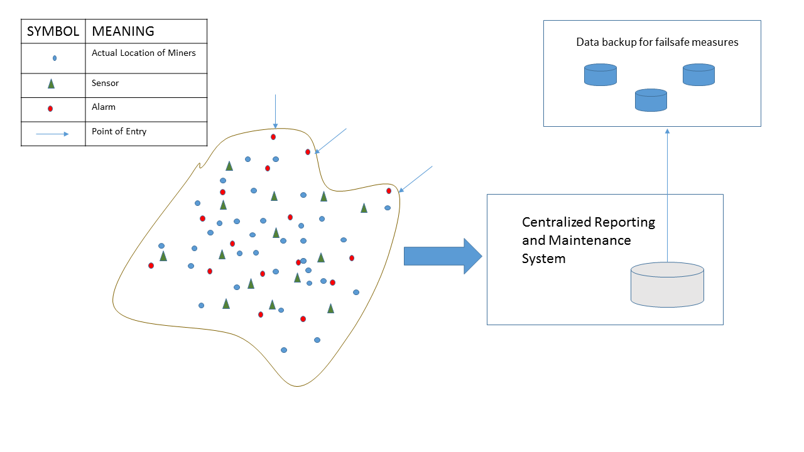

Figure 4

### Partner or Collaborative Applications

In our project, the sensors that we will be using are the products of other companies. We need to collect information from all the sensors and consolidate it in our final software, which will generate a graph and based on the graph reading the system will notify if anything has been sensed higher than the threshold set by us.

Now how are we going to collaborate all these instruments’ data. Most of these sensors comes with a preloaded sensor reader but how will we transfer the data from different sensors to our system. Even after transferring, the next step will be how to store the data provided by the sensors and then analyze them and manipulate them. When the readings are higher than threshold we have set, we want the ventilators to start in case toxic gas level increases, we want machines to stop when overburdened and we want the mining process to be stopped when surface vibration increases. All of this will be achieved using **Internet of Things**.

### Off-the-Shelf Software

**Weka:** This is an open source tool which will be used for predictive modeling. It has preexisting algorithm which can directly be applied on Data Set of products analytics engine.

**SQL Power Architect:** This is an open source Data Modeling tool which will be used for Data profiling by connecting to our Database using standard JDBC connection.

**MySQL:** An Open Source Relational Database Management System(RDBMS)

**Eclipse:** An Open Source Java IDE.

### Anticipated Workplace Environment

The main group of people who will be using this product are the Mine Workers. The users will have their hands busy, which means that the product must be attached some place where it will not get in their way. Since mining conditions can be physically intensive, the product must be relatively light to minimize the stress on the workers. The product's alert/communication system must be loud or/and provide more than audible signals because of the loud machinery miners are likely to face.

### Schedule Constraints

Unlike most of the products, this product does not emphasize on aesthetics of the product. The end users of this product turn out to be miners and the safety crew on board at the mining stations who would consider the safety measures to be relayed quickly rather than in aesthetical manner. Hence, a basic but powerful UI would be enough for the product.

Moreover, as this project is an extension to WSN coupled with Data Analytics, the primary structure revolves around the sensors and the alarms in the mines. Hence, schedule would be made such that all the sensor network be fitted in the mines with alarm system before putting all the efforts in UI. Centralizing the system can be deferred to a secondary state of priority.

Furthermore, functionalities like report generations and data analytic tools may be worked upon in the later stages.

All these stages would ensure a safety-first approach as the environment is hazardous in nature.

### Budget Constraints

This product is primarily aimed at the Market of Small Scale Coal Mines(SCMs) which is an industry that occupies considerable number of shares in the energy production of a developing nation.

They have considerable economic and safety problems. Considering this aspect, the product aims to achieve a low-cost vs value ratio.

## Naming Conventions and Definitions

### Definitions of Key Terms

**Mine -** When we are saying mines, we are not specific to any particular type of mine, the mines can be either a surface mine or sub-surface(underground) mine.

**IoT -** IoT means Internet of Things and in our project, is the internetworking of the devices like sensors to our system.

**Ventilators** - Ventilators in mines are used to provide flow of air which dilutes the noxious air present inside the mines, removes dust and maintains the temperature, and is mostly used in subsurface mining.

**Miners -** Miners are usually the workers who are doing the physical work in the mines and does not include designers and technical people. They have the roles of hewer, driller, loader, putter, etc.

**Sensors** - The sensor in the project are basically of 3 different types: toxic/flammable gas detector, equipment failure detector, ground/surface vibration detector and we are using the sensors from other companies.

**System -** System refers to the collaboration of all these sensors’ output to our device which will show the different readings from all the sensors and based on that will take an action.

### UML and Other Notation Used in This Document

All the UML notations used in the project will follow Version 2.0 UML standard as described in ‘UML Distilled: A Brief Guide to the Standard Object Modelling Language’.

Most of the mine safety operations in the project will be in accordance to the provisions of ‘The Federal Mine Safety and Health Act of 1977 (Mine Act)’ regulated by ‘The Mine Safety and Health Administration (MSHA)’.

### Data Dictionary for Any Included Models

The metrics that we are going to use for our project usually will be the SI units to avoid confusions:

* Volume - meter^3
* Tension - Newton/meter
* Concentration - molar/(meter^3)
* Vibrations frequency - hertz

Also, the way we are going to measure any fault in our system is represented below:

1. Toxic/flammable gas reading >= Threshold (toxic gas) => Ventilator and alarm starts
2. Ground/Surface tension reading >= Threshold (ground/surface tension) => Alarm starts
3. Equipment tension increases >= Threshold (that equipment) => Equipment is stopped and inspected

## Relevant Facts and Assumptions

### Facts

* The product will not function in power outage scenario, it will send out a distress signal to safety manager informing that the product is not providing it’s functionality
* If pulse rate breaches the 50-140 level, the system will identify it as a crisis.
* Carbon Monoxide (CO) level above 50 ppm is identified as dangerous level.
* The maximum safe methane concentration would be 1,000 ppm for 8 hours
* Wireless Sensor Network (WSN) will be used for capturing the data from sensors

### Assumptions

* The sensors used by the product should be able to produce output which the software can interpret.
* The software performs computations and has some built in settings for which it will trigger an alarm, but this is NOT the case for all situations. It will display patterns in which other systems have failed before, but it's up to the Manager to make the call of whether it's a hazardous situation or not in those cases.
* If sensors fail, it's expected that the company replaces them with working ones. The software will NOT try to simulate missing sensor data, and so if a sensor is broken and not detecting correct input, it's up to the company to fix it.
* The sensors used by the software should be durable and the rough mining conditions should be taken into account when the company purchases them.
* The software uses a GPS system, so it's expected that the mines which include it have a network connection. If such a connection exists but disconnects at some point, it's up to the software to report the issue / trigger an alarm.
* The software can use both radio and network communication for communicating between managers and workers, so either / both is expected to be available.
* The software will NOT check sensors if they work properly, it's the job of the person in charge of maintenance to ensure that.

# Requirements

## Product Use Cases

### Use Case Diagrams

* Use case diagram for hardware oriented cases:

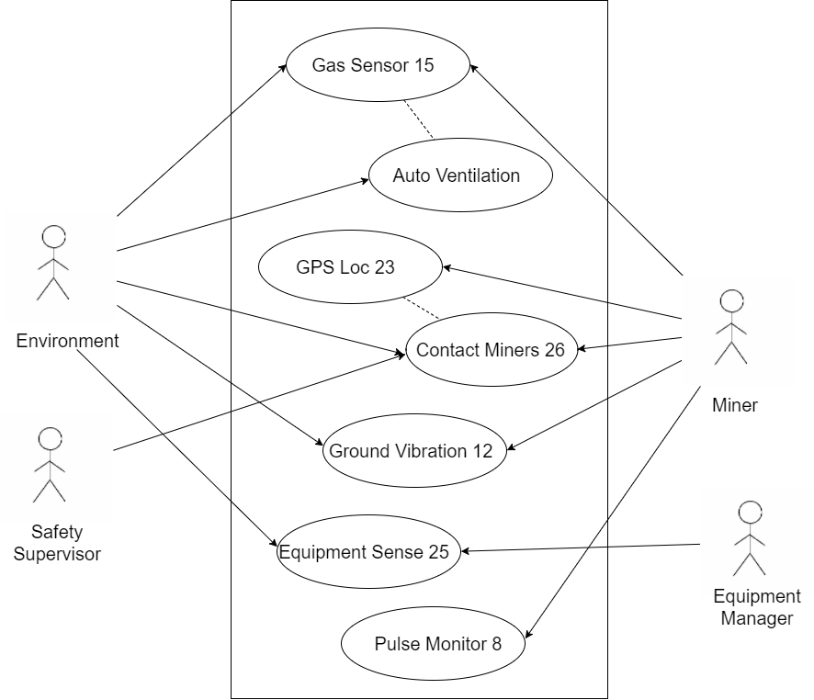

* Use case diagram for central system related cases:

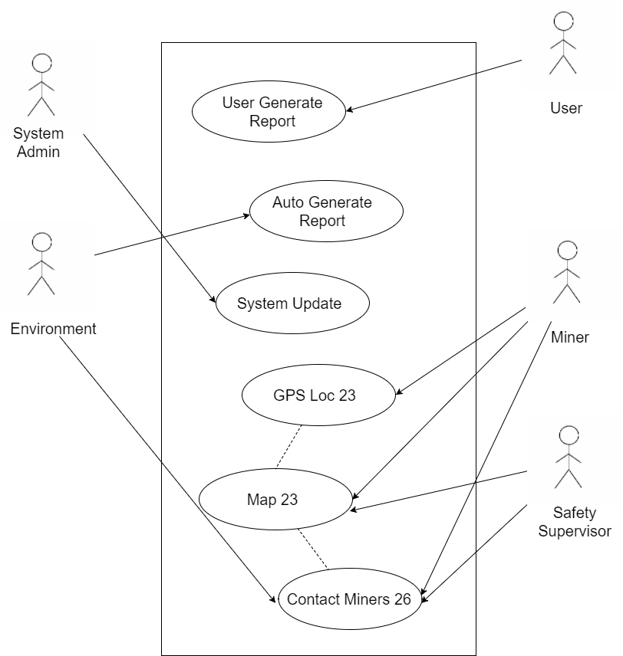

Figure 5

### Product Use Case List

|  |
| --- |
| ReportGenerate1 |
| ReportGenerate2 |
| AutoVentillation |
| SystemUpdate1 |
| PulseMonitor8 |
| GasSensor15 |
| EquipmentSense25 |
| ContactMiners26 |
| GroundVibration12 |
| GPSLoc23 |
| Map23 |

### Individual Product Use Cases

|  |
| --- |
| **Use Case ID:** ReportGenerate1 **Name:** Auto Generating a __ Day Report  **Pre-Conditions:** __ days have passed since the software's installation or the previous report generation.  **Post-Conditions:** A __ day report is generated which summarizes the data collected throughout the time period.  **Initiated By:** Environment (Time)  **Triggering Event:** __ days have passed since the software's installation or last report generation.  **Additional Actors:** |
| **Sequence of Events:**     1. __ days have passed since the software's installation or last report generation.  2. System checks if a report has been generated already. If one hasn't been generated yet, proceed.  3. System obtains necessary data from database and generates report in a predefined default format. |
| **Alternatives:** A report has been generated, so the system will not create a new one.  **Exceptions:** |

|  |
| --- |
| **Use Case ID:** ReportGenerate2 **Name:** Manually Generating a Report  **Pre-Conditions:** User is on the report generation menu.  **Post-Conditions:** A report is generated which summarizes the data collected throughout the time period the user has selected.  **Initiated By:** User  **Triggering Event:** User selects generate report option  **Additional Actors:** |
| **Sequence of Events:**     1. User selects generate report option  2. System prompts for a specific time period range for which to generate the report on.     3. User inputs the desired time period.  4. System prompts with different sensor options (All Data, Geo Sensor Data, Gas Sensor Data, etc.)     5. User selects desired data sets  6. System prompts for a file format to generate the report with (e.g. PDF, CSV, etc)     7. User selects desired format  8. System generates a report for the desired time period with the desired data and format. |
| **Alternatives:** There is not enough data to generate the report on the requested time period  **Exceptions:** |

|  |
| --- |
| **Use Case ID:** AutoVentillation **Name:** Automatic Ventilation Turns On  **Pre-Conditions:** Gas sensors are functioning properly and sending data to the central system  **Post-Conditions:** The central system turns on the automatic ventilation  **Initiated By:** Environment  **Triggering Event:** Methane gas has built up in the environment around the sensor and breached a certain threshold  **Additional Actors:** |
| **Sequence of Events:**     1. Methane gas has built up in the environment around the sensor and breached a certain      threshold  2. System receives abnormal reading and detects it's over the safe amount.  3. System initiates automatic ventilation system.     4. Methane gas levels slowly decrease |
| **Alternatives:**   * Methane gas levels keep rising despite ventilation   **Exceptions:** |

|  |
| --- |
| **Use Case ID:** SystemUpdate1 **Name:** Admin Updates System  **Pre-Conditions:** User has received an update notification  **Post-Conditions:** The software / system is updated to the newest build and functions with no trouble.  **Initiated By:** Admin  **Triggering Event:** Admin selects update system option during non operational hours  **Additional Actors:** |
| **Sequence of Events:**     1. Admin selects update system option  2. System prompts for verification and displays the size of the update.     3. Admin confirms the update  4. System begins downloading / installing the update and displays an estimated time.     5. Admin waits until system has been updated  6. System displays an update successful message and tells the user to restart the software to apply changes     7. Admin restarts software  8. System is now updated and functions properly |
| **Alternatives:**   * There is not enough space to download the update. * Internet connection disconnects while downloading the update.   **Exceptions:** |

|  |
| --- |
| **Use Case ID:** PulseMonitor08 **Name:** Pulse rate monitor.  **Pre-Conditions:** Miners working in the mine.  **Post-Conditions:** The affected miner could be treated rapidly and given proper medical attention.  **Initiated By:** User  **Triggering Event:** The heart rate sensor shall issue an alert if an abnormal pulse rate is detected from the pulse rate monitors which each mine worker wears.  **Additional Actors:** |
| **Sequence of Events:**  The user is working in the mines when he might suffer a sudden attack which might cause his body vitals to alter.   1. The heart rate sensor shall issue an alert if an abnormal pulse rate is detected from the pulse rate monitors.   3. The base station and the miners near the user are alerted of the situation.  4. The affected user receives the medical attention. |
| **Alternatives:**  **Exceptions:** |

|  |
| --- |
| **Use Case ID:** GasSensor15 **Name:** Gas Sensor for inflammable/toxic gases  **Pre-Conditions:** Miners working in the mine.  **Post-Conditions:** The area is secured, and the inflammable/toxic gases are neutralized.  **Initiated By:** Environment  **Triggering Event:** Drilling into the rocks or use of explosives may release these gases.  **Additional Actors:** Miners |
| **Sequence of Events:**   1. Drilling into the rocks or use of explosives may release inflammable/toxic gases. 2. The infrared or catalytic gas sensor records the amount of these gases at all times.   If the amount of gas reaches above a threshold, the sensor alerts the central system and sends a signal to the corresponding alarm.   1. The miners evacuate the affected area.   opt  System would keep checking for presence of the harmful gases in the environment for __ minutes before resuming work.   1. The alarms would stop after the area is secured. |
| **Alternatives:** Check step 5.  **Exceptions:** |

|  |
| --- |
| **Use case ID:**  Equipmentsense25                           **Name:** Sensor for equipment  **pre-conditions:** Heavy equipment in use at the mining site.  **post-conditions:** Equipment is safe to use; any wear and tear is identified and undue stress is taken care of.  **Initiated by:** Equipment used excessively or the Environment.  **Triggering Event:** Rise in stress above threshold level recorded by equipment sensor.  **Additional Actors:** Equipment supervisor |
| **Sequence of Events:**  1.Heavy equipment use result in rise in stress on equipment.  2.System identifies ries in equipment stress.  3.System triggers an alarm if it detects rise to be above threshold level.                         4.Equipment supervisor receives notification of rise in stress.                         5.Equipment is taken care of and the rise in stress catered so that it will not result in failure  6.System receives the resolution through update in sensor value or absence of sensor feed if the equipment has been removed from the site.  7. System shuts the trigger down and normal operation resumes. |
| **Alternatives:** None  **Exceptions:** None |
|  |

|  |
| --- |
| **Use case ID:**  ContactMiners26                           **Name:** Means to contact miners for rescue  **pre-conditions:** Miners underground and mining supervisor needs to make contact with them.  **post-conditions:** Contact established with miners and rescue operation proceeds safely.  **Initiated by:** Environment.  **Triggering Event:** Rise in level of toxic gases.  **Additional Actors:** Mining supervisor, Miners |
| **Sequence of Events:**  1.Blast in mines results in rise in level of methane gases.  2.System identifies the rise of methane above safe level.  3.System triggers an alarm notifying mining supervisors and miners.                         4.Mining supervisor contacts miners to guide them to safe rescue.                         5.Contact established and mining supervisor feeds minors useful information for rescue.  6.Mine condition stabilizes and normal condition prevails .  7.System returns to normal operation, trigger is shut down. |
| **Alternatives:** None  **Exceptions:** None |
|  |

|  |
| --- |
| **Use case ID:** GroundVibration12 **Name:** Vibration of roof and ground  **pre-conditions:** Miners working in the mine with drilling equipment or explosives.  **post-conditions:** The area is secured, and the possibility of cave-in avoided.  **Initiated by:** Environment or mining equipment used excessively.  **Triggering Event:** Vibrations inside the mine seen through geophone sensor.  **Additional Actors:** Miners |
| **Sequence of Events:**   1. The roof of a mine or the ground may become loose due to natural reasons or due to excessive or wrong usage. 2. The geophone sensor looks around for change in energy levels on the ground or roof level. If the amount of gas reaches above a threshold, the sensor alerts the central system and sends a signal to the corresponding alarm.   The miners evacuate the affected area.  4. opt  System would keep checking for presence of the harmful gases in the environment for ___ minutes before resuming work.  5. The supervisor disables the alarm when the area is secured. |
| **Alternatives:** Check step 4.  **Exceptions:** |

|  |
| --- |
| **Use case ID:** GPSLoc23 **Name:** GPS tracking  **pre-conditions:** Miners working in the mine with GPS tracking device.  **post-conditions:** The miners are safe and secured.  **Initiated by:** Miner.  **Triggering Event:** Movement of a miner.  **Additional Actors:** N/A |
| **Sequence of Events:**   1. Within a mine there is a lot of movements of miners. 2. The gps tracking sensor looks around for change in positions of a miner within an area covered by the mine.   If the miner crosses the mine boundary then immediately it is notified.  4. opt  System would keep checking for movements of employees.  5. The supervisor if finds the person moving from the mine boundary, immediately asks the miner manager. |
| **Alternatives:** Check step 4.  **Exceptions:** |

|  |
| --- |
| **Use case ID:** Map23 **Name:** Map of mine with the locations of all features  **pre-conditions:** All the sensors and alarms are set up and functioning properly and miners working in the mine.  **post-conditions:** A map with real time data is displayed on the screen.  **Initiated by:** User (Supervisor)  **Triggering Event:** Clicking on the button for displaying the real-time map.  **Additional Actors:** Miners, Sensors, Alarm, Screen |
| **Sequence of Events:**   1. The user clicks on the button for displaying the map of the mine at real time. 2. The system reads the locations of sensors and alarms and displays on the map. 3. The system takes the location of the miner at real-time using the GPS sensor of the miner at real-time.   4. loop  The location of the miner is updated every time he/she moves.  5. The user sees the data at real time. |
| **Alternatives:**  **Exceptions:** |

## Functional Requirements

|  |
| --- |
| **Requirement #:** 1 **Requirement Type: Event/Use Case #:**  **Description:** The product shall issue an alert if an infrared or catalytic sensor detects  a toxic / flammable gas above the safety threshold.  **Rationale:** Too much toxic or flammable gas can cause harm to mine workers which results in a hazardous situation.  **Originator:** Marvin Snow - Safety Supervisor  **Fit Criterion:** For each infrared or catalytic sensor, the recorded number of each reading per hour shall be within the manufacturer's specified expected number of readings per hour.  **Customer Satisfaction:** 3 **Customer Dissatisfaction:** 5  **Priority:** High  **Supporting Materials:**  **History:** Created October 31, 2017 |

|  |
| --- |
| **Requirement #:** 2 **Requirement Type: Event/Use Case #:**  **Description:** The product shall issue an alert if a geo sensor detects an abnormally high ground level vibration.  **Rationale:** Too high of a ground vibration can potentially cause cave ins which endanger the lives of mine workers.  **Originator:** Marvin Snow - Safety Supervisor  **Fit Criterion:** For each geo sensor, the recorded number of each reading per hour shall be within the manufacturer's specified expected number of readings per hour.  **Customer Satisfaction:** 3 **Customer Dissatisfaction:** 5  **Priority:** High  **Supporting Materials:**  **History:** Created October 31, 2017 |

|  |
| --- |
| **Requirement #:** 3 **Requirement Type: Event/Use Case #:**  **Description:** The product shall issue an alert if an equipment sensor (thermo resistive and pressure sensors, and strain gauges) detects an equipment which shows signs of failure or worn out material.  **Rationale:** Equipment failure can the occurrence of a hazardous situation or potentially fatalities for mine workers. Equipment failure can create bigger sparks than normal which lead to flammable gas exploding, or the equipment itself can blow up.  **Originator:** Marvin Snow - Safety Supervisor  **Fit Criterion:** For each equipment sensor, the recorded number of each reading per hour shall be within the manufacturer's specified expected number of readings per hour.  **Customer Satisfaction:** 3 **Customer Dissatisfaction:** 5  **Priority:** High  **Supporting Materials:**  **History:** Created October 31, 2017 |

|  |
| --- |
| **Requirement #:** 4 **Requirement Type: Event/Use Case #:**  **Description:** The product shall issue an alert if an abnormal pulse rate is detected from the pulse rate monitors which each mine worker wears.  **Rationale:** Abnormal pulse rates indicate that a miner is potentially in distress and may be in danger. The safety supervisor should confirm the situation if this alarm goes off.  **Originator:** Marvin Snow - Safety Supervisor  **Fit Criterion:** For each infrared pulse rate monitor, the recorded number of each reading per hour shall be within the manufacturer's specified expected number of readings per hour.  **Customer Satisfaction:** 3 **Customer Dissatisfaction:** 5  **Priority:** High  **Supporting Materials:**  **History:** Created October 31, 2017 |

|  |
| --- |
| **Requirement #:** 5 **Requirement Type: Event/Use Case #:**  **Description:** The product shall use a GPS system to track every miner's and every sensor's location in the mine.  **Rationale:** It is vital that the location of all mine workers is known so that in the case of an emergency, the safety supervisor can evacuate the appropriate workers in the corresponding section of the mine. It is also vital that the location of all sensors is known so that the mining company can confirm that no areas are left uncovered by the sensors.  **Originator:** Marvin Snow - Safety Supervisor  **Fit Criterion:** The GPS system's real time updates, preciseness, and range shall be within the manufacturer's specified range of the expected values.  **Customer Satisfaction:** 3 **Customer Dissatisfaction:** 5  **Priority:** High  **Supporting Materials:**  **History:** Created October 31, 2017 |

|  |
| --- |
| **Requirement #:** 6 **Requirement Type: Event/Use Case #:**  **Description:** The product shall analyze data and display it in a visually friendly format from sensors and alert if a fault or discrepancy is seen from the normal patterns.  **Rationale:** It is vital that the the system is able to analyze and identify discrepancies in patterns because such behavior may result in unknown behavior which could be dangerous. The alert should notify the personnel to proceed with caution.  **Originator:** Marvin Snow - Safety Supervisor  **Fit Criterion:** The data analyzed will show a steady state of readings or a consistent pattern with the readings received from the sensors. Irregular patterns will diverge from the norm.  **Customer Satisfaction:** 4 **Customer Dissatisfaction:** 4  **Priority:** High  **Supporting Materials:**  **History:** Created October 31, 2017 |

|  |
| --- |
| **Requirement #:** 7 **Requirement Type: Event/Use Case #:**  **Description:** The product shall visually display a map of the mine with the locations of all miners and sensors.  **Rationale:** Having a visual of the mine is extremely helpful in determining where people are located relative to each other and which areas are covered by sensors and which are not.  **Originator:** Marvin Snow - Safety Supervisor  **Fit Criterion:** The GPS location on the visualization shall match with the GPS tracker on each sensor used.  **Customer Satisfaction:** 4 **Customer Dissatisfaction:** 4  **Priority:** High  **Supporting Materials:**  **History:** Created October 31, 2017 |

|  |
| --- |
| **Requirement #:** 8 **Requirement Type: Event/Use Case #:**  **Description:** The product shall trigger a warning if there is an operational area which is not covered by a sensor.  **Rationale:** Working in an area which doesn't have any sensors to watch for potential hazards is very dangerous and so people should be warned to proceed with care when working there.  **Originator:** Marvin Snow - Safety Supervisor  **Fit Criterion:** The sensors in use have a specific range which they operate in, and so if an area is expanded in which the sensor doesn't reach, that can be documented.  **Customer Satisfaction:** 4 **Customer Dissatisfaction:** 4  **Priority:** High  **Supporting Materials:**  **History:** Created October 31, 2017 |

|  |
| --- |
| **Requirement #:** 9 **Requirement Type: Event/Use Case #:**  **Description:** The product shall automatically turn on the mine's ventilation in an area if a gas reading has reached a threshold in the said area.  **Rationale:** Automatically triggering the ventilation will reduce the risk of toxic / flammable gas building up and extend the work time of miners.  **Originator:** Marvin Snow - Safety Supervisor  **Fit Criterion:** The ventilation does turn on in the designated area within seconds of the abnormal readings.  **Customer Satisfaction:** 3 **Customer Dissatisfaction:** 4  **Priority:** Medium  **Supporting Materials:**  **History:** Created October 31, 2017 |

|  |
| --- |
| **Requirement #:** 10 **Requirement Type: Event/Use Case #:**  **Description:** The product shall have a means of allowing the supervisor to contact individual miners or groups of them at will.  **Rationale:** Having contact with the person who watches over the mine workers and the workers themselves is vital when cases arise which the sensors don't trigger an alert for.  **Originator:** Marvin Snow - Safety Supervisor  **Fit Criterion:** The safety supervisor and a worker / group of workers are connected and are communicating in real time with no delay.  **Customer Satisfaction:** 3 **Customer Dissatisfaction:** 5  **Priority:** High  **Supporting Materials:**  **History:** Created November 1, 2017 |

|  |
| --- |
| **Requirement #:** 11 **Requirement Type: Event/Use Case #:**  **Description:** The product shall produce appropriate graphs and chart to visualize data trends and patterns.  **Rationale:** Being able to visualize trends helps determine dangerous areas and patterns which could lead to hazardous situations.  **Originator:** Marvin Snow - Safety Supervisor  **Fit Criterion:** The graphs and charts shall correctly represent the gathered data from the sensors.  **Customer Satisfaction:** 4 **Customer Dissatisfaction:** 3  **Priority:** Medium  **Supporting Materials:**  **History:** Created November 1, 2017 |

|  |
| --- |
| **Requirement #:** 12 **Requirement Type: Event/Use Case #:**  **Description:** The product shall produce a monthly report which contains a collection of all the data analyzed as well as potential hotspots which might be unsafe.  **Rationale:** Having such a report is useful for identifying features which may be overlooked normally and can also be provided to government appointed safety inspectors during their check ups.  **Originator:** Marvin Snow - Safety Supervisor  **Fit Criterion:** The information in the report shall correctly represent the data gathered during the month.  **Customer Satisfaction:** 4 **Customer Dissatisfaction:** 2  **Priority:** Medium  **Supporting Materials:**  **History:** Created November 1, 2017 |

|  |
| --- |
| **Requirement #:** 13 **Requirement Type: Event/Use Case #:**  **Description:** The product shall alert both the users in an endangered area and the central system when a hazardous situation is present.  **Rationale:** The users need to know when to evacuate when needed and they need to be notified in order to do so. The central system is also notified so that the supervisor may take action accordingly and be prepared for anything that might occur.  **Originator:** Marvin Snow - Safety Supervisor  **Fit Criterion:** The user shall be notified accordingly if the central system determines that there is a potential hazard.  **Customer Satisfaction:** 3 **Customer Dissatisfaction:** 5  **Priority:** High  **Supporting Materials:**  **History:** Created November 1, 2017 |

|  |
| --- |
| **Requirement #:** 14 **Requirement Type: Event/Use Case #:**  **Description:** The system shall have information on seismic activities in a region beyond the expanse of the mines in order to be aware of any earthquakes that may occur in the neighbouring regions.  **Rationale:** Seismic activities from a different region may not affect the region of  the mine but can have grave consequences in the environment below ground level  in forms of cave-ins.  **Originator:** Marvin Snow - Safety Supervisor  **Fit Criterion:** The data used must be accurate with the seismic monitors from neighboring / outside regions.  **Customer Satisfaction:** 3 **Customer Dissatisfaction:** 3  **Priority:** Medium  **Supporting Materials:**  **History:** Created November 1, 2017 |

|  |
| --- |
| **Requirement #:** 15 **Requirement Type: Event/Use Case #:**  **Description:** The product shall fail safely. It will send out a distress signal to the safety manager informing that the product is not providing it's functionality.  **Rationale:** Alerting when the system goes down is vital for safety precautions. The users must know when this has happened so that they may evacuate and stop operations to avoid endangering themselves.  **Originator:** Marvin Snow - Safety Supervisor  **Fit Criterion:** The user shall be alerted in case of a system failure properly via an alarm.  **Customer Satisfaction:** 3 **Customer Dissatisfaction:** 5  **Priority:** High  **Supporting Materials:**  **History:** Created November 1, 2017 |

|  |
| --- |
| **Requirement #:** 16 **Requirement Type: Event/Use Case #:**  **Description:** The product shall provide a means of registering and removing sensors which are in turn added or removed from the system.  **Rationale:** Maintaining up to date sensors as the mine expands and as sensors break and need to be replaced is vital to ensure hazardous situations are prevented.  **Originator:** Marvin Snow - Safety Supervisor  **Fit Criterion:** The registered or removed sensors shall appear or disappear from the database of the system when added / removed.  **Customer Satisfaction:** 3 **Customer Dissatisfaction:** 5  **Priority:** High  **Supporting Materials:**  **History:** Created November 1, 2017 |

|  |
| --- |
| **Requirement #:** 17 **Requirement Type: Event/Use Case #:**  **Description:** The system shall be easily updatable and backwards compatible.  **Rationale:** Ease of update is essential as often times the user who installs the system might not have strong computer knowledge. Backwards compatibility is necessary as to avoid loss of data or tedious transferring of files.  **Originator:** Scott - Lead Engineer  **Fit Criterion:** The performance shall be approved by the development team.  **Customer Satisfaction:** 2 **Customer Dissatisfaction:** 5  **Priority:** Medium  **Supporting Materials:**  **History:** Created November 2, 2017 |

|  |
| --- |
| **Requirement #:** 18 **Requirement Type: Event/Use Case #:**  **Description:** The reports generated by the system shall be in an easily readable format.  **Rationale:** Formats such as PDF, CSV, XLSX, etc. are widely used and so the system should strive to use one of those in order to lessen the overhead time when communicating / sending files.  **Originator:** Scott - Lead Engineer  **Fit Criterion:** The generated report's format shall be within one of the most used ones in the present day.  **Customer Satisfaction:** 3 **Customer Dissatisfaction:** 3  **Priority:** Medium  **Supporting Materials:**  **History:** Created November 2, 2017 |

|  |
| --- |
| **Requirement #:** 19 **Requirement Type: Event/Use Case #:**  **Description:** The sensors used shall transmit all data to the central system wirelessly.  **Rationale:** Wireless transmission is important in mining conditions as having wires running along the entire mine can cost a lot as well as have a risk of getting damaged.  **Originator:** Scott - Lead Engineer  **Fit Criterion:** The central system receives data from sensors which is consistent with the actual readings from them.  **Customer Satisfaction:** 4 **Customer Dissatisfaction:** 5  **Priority:** Medium  **Supporting Materials:**  **History:** Created November 2, 2017 |

|  |
| --- |
| **Requirement #:** 20 **Requirement Type: Event/Use Case #:**  **Description:** The data reports gathered by the system shall be publicly available to all personnel who work at the mine.  **Rationale:** This is important so that mine workers can always read the reports and know what risk they are in or what conditions they have been working in in full detail.  **Originator:** Scott - Lead Engineer  **Fit Criterion:** The accessibility shall be confirmed with all personnel working at the mine.  **Customer Satisfaction:** 4 **Customer Dissatisfaction:** 3  **Priority:** Medium  **Supporting Materials:**  **History:** Created November 2, 2017 |

## Data Requirements

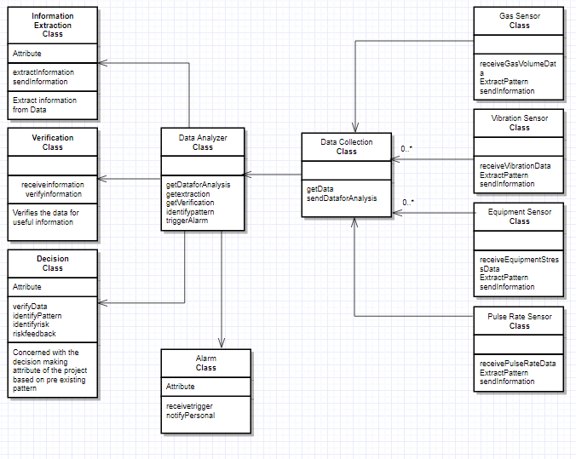

Figure 6

## Performance Requirements

### Speed and Latency Requirements

* 5 seconds is considered as a benchmark for real-time in this product.
* Fibre Channel Switch to implement Storage Area Network, as the system needs to be real-time.
* Data collected from sensors should be refreshed every 5 second.
* Information extraction and Data analysis should be done for the given data set before fresh batch of data set arrives in analyzing unit.
* Once a crisis situation is identified, trigger of alarm and notification out to concerned authorities and miners should be done in a time span of 5 seconds.
* On triggering of alarm situation, system should keep on continuing its function and there should be no latency for fresh datasets.
* System should process data independently of storage operation for achieving low latency.
* System should be in a condition to identify multiple failure without any latency.

### Precision or Accuracy Requirements

* Accuracy of gas sensors should be in a range of 90+ percentage.
* Since sensors are required to cover large areas of mines underground, they should be capable to provide accurate readings for multiple locations.
* Sensors should be capable to work in harsh condition of mines with high humidity and heat.
* Imperfect or missing data needs to be handled to get an accurate information.
* The prediction of risk should have high accuracy since the resolution action following alarm trigger involves lots of manpower.

### Capacity Requirements

* System should be scalable as mine site may require new sensors to be installed.
* System is a data intensive product which can have data range greater than 5 TB, so the product needs to have Ram greater than 32 GB.
* Since system detects multiple failures at the same instance, it needs to have multiple alarms triggering system.

## Dependability Requirements

### Reliability Requirements

The product shall not fail more than once per week. It may occur due to technical problems, like bad connectivity and failure to some equipment’s due to mining activities. In a mining activity a lot of activities like cutting, blasting, etc. keep on going, which may result in failure of an equipment like a sensor, which is a rare scenario since we position the sensors well after few initial calculations. So, the chances of equipment failure are minimal.

Even if the sensor fails, the person who is monitoring the sensors will realize that there is some issue with the sensors since there will be some glitches in the data and it will give unusual variations in data. For example, if the expected level of methane released from a coal mine is 0.09%, but the sensor shows 0.2% due to the damage to itself, the person monitoring it will quickly pay attention to it and realize that the data is wrong and will immediately ask the technical team to verify it, to which the installation team will fix the sensor or if required may replace it. Since with the product we are providing monthly inspections and support 24 by 7, so our customers do not have to worry for our product’s reliability.

As there are multiple sensors, and since we are calculating the mean of data from all the sensors, the final data is generated using all the sensors and will have very insignificant amount of distortion, thus maintaining the safety of miners.

### Availability Requirements

Since the mining activities usually run 24 by 7 and miners are present in mines in shifts, the product will be available and in running state 24 by 7 from the start of mining until the mining activities are finally stopped. The product will never fail but mining activities like blasting, cutting, etc. may damage the product(sensors) and thus alter the data generated to a very insignificant value.

As mentioned in section 13a, the sensors will be immediately replaced by the installation team after verification from the technical team. Our product must produce accurate data because we are monitoring various safety standards of the mines and the lives of miners depend on the product, so we ensure that all the sensors are intact and in case of any suspicion in the working of any sensor, an immediate support is provided to the customer.

### Robustness or Fault-Tolerance Requirements

The mining itself is done in a very tumultuous environment. A lot of drilling, cutting, blasting using explosives, and other kind of activities are done during mining. These activities also release a lot of dust and stones which may damage the product. To tolerate all these activities, we have ensured that our product(sensors) is well encapsulated in a protective shield and also have small holes so that its primary function of sensing is not compromised.

Our sensors are not wired, so the power failure will not affect them, but what about the data collected from the sensors? These data are sent using WIFI to the cloud and thus the person monitoring these activities, who is physically not present in mine may not receive it. The WIFI in the system also has a battery backup which will gives few hours of backup when power failure occurs. Thus, we ensure that the data is collected even in case of any abnormal conditions.

### Safety-Critical Requirements

Our product is made of different components and we make sure they are standardized. For safe electrical wiring of WIFI and sensors, we use NFPA 70 or National Electric Electrical Code. It is typically adopted by states and municipalities to standardize their enforcement of safe electrical practices.

We also make sure that mining standards are always followed, and the mining customer does not violate any safety law. For this we set the threshold for all the sensors like for methane we set 0.09% since National Institute for Occupational Safety and Health’s (NIOSH) maximum recommended safe methane concentration for workers during an 8-hour period is 1,000 ppm (0.1 percent). This is because methane is considered an asphyxiant at extremely high concentrations and can displace oxygen in the blood.

Our technical team during the product release sit with our legal advisor who guides us about the permissible guidelines and we accordingly modify the threshold of the data. This is done for all the customers as a customer may be from a different country and different countries have different rules and standards.

## Maintainability and Supportability Requirements

### Maintenance Requirements

Due to the rugged surroundings and activities in the mines, it may happen that one of the sensor malfunctions and does not give good result to generate data. This deviation in data will be identified by the person monitoring the data. He will contact our support team and the support team will immediately take action on it.

Along with it we will provide a monthly inspection by our technical team who will check if all the sensors and heart rate monitors are working properly. The cost of inspection will be included in the product itself. This will make sure our product is intact and in working condition, thus decreasing the failure rate of product.

We will provide initial training to the person who will be monitoring the data, so that he will understand the charts and data produced by the sensors. With the product we will also provide an instruction manual to our customer, so that they understand what each generated data means. They may also look our website which has tutorial videos about installation and data chart details to give them a clear understanding of the product. It will also help the miners how to wear the heart-rate equipment as well as GPS tracker.

### Supportability Requirements

The customers may reach our product support team in case they find any problems with the system. Our support team will be available at a time to save some cost, but we will allow them to mail us on which we will take immediate action. They can find our contact details at our website. They may also use our website to file questions related to our product.

We will also take feedback from our customers on a regular basis about our product thus constantly trying to work at areas where we need to improve.

### Adaptability Requirements

We will provide login credentials to the customers. These login credentials will help them access our website where all their mine data will be generated. Since the data is stored in cloud, they can see all their data as well as history. This will also help us provide them a better support when anything malfunctions as we can see their data being the administrator and give them immediate support.

Since the application is online, there is no restriction to using windows mac OS or Linux. The website will be in English and we may later add other language as we will increase our customer base.

All the data that is generated in reports will be in SI units to avoid any confusion amongst customers and our team.

● Volume - meter^3

● Tension - Newton/meter

● Concentration - molar/(meter^3)

● Vibrations frequency - hertz

### Scalability or Extensibility Requirements

Our product is customer specific product. We build it according to the needs of customer. Some mines are big, and some are small. Small mines may need less number of sensors, but a large mine may need a lot of sensors. Large mines will have more miners and so more GPS devices and heart-rate monitors will be needed. Similarly, small mines will have less miners, therefore less GPS and heart-rate devices will be needed. So, the price of the product will also vary.

As the customers will increase, our server should be able to handle the data from all of them. These data must be updated in real time and, so we expect our system to process 1000 instructions per minute from one customer. The total instructions will gradually grow as our customers increase and thus we will need big servers to interact and large database to store huge data.

### Longevity Requirements

The product will run for a maximum of 4 months and then will need a total overhaul. The time duration is less since mining activities is done in a very rugged environment. They cause a lot of dust accumulation and the continuous running of product makes the product weary. Thus, the product needs to be replaced and we will offer exchange of the old product with the new one at a lesser price to our existing customers.

This exchange will help us save capital by working on the old products, repair them and polish them to make it a new state, thus helping us save our resource which includes finance as well as parts of product.

## Security Requirements

### Access Requirements

* Only site manager and authorized system users will have access to the system.
* Only system administrator will have access to initiate reboot or shut down the system.
* The reboot or system shut down will be based on four eye principles, where system owner will approve the action of administrator after which the action will complete.
* System should notify system administrator in case when there are 3 failed tries to gain authorization.

### Integrity Requirements

* System must identify and report information flaws it encounters.
* Only system administrator will have access to application level code.
* Developers will not have access to production code and data.
* Network integrity needs to be ensured.
* System must ensure that data is not modified or deleted without authorization.
* Unauthorized access to data must be reported as security incident.
* System should log each detail of information flow and only administrator will have access to system logs.
* All system reboots must be logged.
* All user activity needs to be logged in each separate individual file.
* System should reject incompatible data.

### Privacy Requirements

* No personal identification information of any individual will be maintained by system.
* The information from pulse rate devices worn by miners will be maintained in privacy and only system administrator will have access to its data.
* Information on mines and installed sensors will be accessible to authorized users only.
* In no way any information contained in the system of previous identified faults will be made available to non-authorized users.

### Audit Requirements

* There will be a monthly architecture review so that it can be upgraded if its required.
* User management needs to be done every month.
* System will have fortnight review of system logs and user logs to identify any fault.
* System will have audit for its network and security configuration every month.
* Each system event needs to be logged.
* System must have a monthly audit for its users privilege.

### Immunity Requirements

* Activity of system will be logged in a file.
* There will be routine scan to find malicious files
* System will have security patches for identified risk areas.

## Usability and Humanity Requirements

### Ease of Use Requirements

The part of the product which is to be used by the miners has to be easy to use and easily taught in training sessions whereas the technical part which would be used by the maintenance crew needs to be robust.

• The heart rate sensors which would be strapped on the miners should be easy to strap on the vests and should not be uncomfortable to the miners while working.

• The heart rate sensors should demand no technical expertise from the miners in learning of how to use it.

• The heart rate sensor should create a loud enough alarm in case of a medical emergency to a miner so as to alert the nearby miners in an environment which generates loud noises in general.

• The alarms that set off would be loud enough to alert everyone in an environment which generates loud noise in general.

• The flashing lights of the alarm should be distinct and strong enough to alert the miners in case of an emergency

• The monitoring system at the base station would be made for users with training in ___ for ___ hours.

• The response generation functionalities at the base station should be easy to use for the operators for a quick response.

• The sensing of all the harmful factors in the mines along with the response generation in the form or alarms should occur at real time without wasting any precious time in what could turn out to be a disastrous environment.

• The reports generated by the system after every ___ days should be understood by a member of the maintenance crew who has had training in ___.

• One month’s use of the product shall result in a total error rate of less than 1 percent.

• An anonymous survey shall show that 75 percent of the intended users are regularly using the product after a three-week familiarization period.

### Personalization and Internationalization Requirements

• The product has to be primarily personalized according to the needs of the miners as they are the key end users of the product.

• The language displayed on the symbols and the safety equipment should be one which would be understood by most of the miners so as to get a quick response form them in case of an emergency situation.

• The symbols and signs that would be displayed should be according to the mining safety standards as miners would be aware of those rather than making new ones and training the miners all over again.

• The alarm noise should be a unique sound as compared to the sound that is usually generated by the mining machinery and equipment such that the miners would be able to differentiate the alarm noise accurately and respond quickly.

• The software required to monitor the entire mining safety system should be a software which the maintenance crew has a good amount of experience so as to avoid the hassle of training.

• The report generated should be in a format which is compatible with the systems at the base station.

### Learning Requirements

• The product shall be easy to learn even for a miner without any academic background.

• The heart rate sensor which would be strapped on a miner would be easy to learn and would not take more than __ hours to learn initially for the miners.

• The miner would be able to learn the sound and flash of alarms due to their distinct nature.

• The maintenance crew would not take more than ___ days to learn how to operate the system.

• The maintenance crew would be able to locate the sensors correctly in the mines due to the GPS sensors fitted in them.

• The two-way communication radio system between the miners and also the crew above ground should be easy to use for all the parties involved.

### Understandability and Politeness Requirements

• The product shall use symbols and signs that are naturally understandable by the mining community.

• The systems would be adjusted in order with the existing mining methods so as to avoid the trouble of training for the miners.

• The language used would be in accordance of the most popular language spoken in the mining community.

• The product shall hide the details of the construction from the users.

• The software used at the base station would be created in an environment which is familiar to the crew avoiding the need for training on another software.

### Accessibility Requirements

The product is mainly focused on miners as the end users who would be working in a hazardous environment. The product makes no considerations towards users with disabilities assuming no such requirement would be needed until instructed specifically by the client.

Assuming that a miner may be color-blind or partially deaf, the flash and sound alarm system should be good enough for the miners to be alerted one way or the another.

### User Documentation Requirements

• Technical specifications to accompany the product:

▪ This document would describe all the technical equipment used in the product with technical specifications.

▪ Some examples of the equipment covered in this document would be the many sensors, alarms and the base station software.

▪ This documentation would be specifically for the maintenance crew and would require no updating until some system is physically changed.

• User Manual:

▪ This document would be a manual for how to use the equipment manually in case of need of a manual override of the system.

▪ The document would be specifically for the maintenance crew and would require no updating until some system is physically changed.

• Installation Manuals:

▪ This document would be used for referral in case if any installation is required after the installation of the system in future instances.

▪ This manual would be specifically for the maintenance crew and would require no updating until some system is physically changed.

### Training Requirements

• The monitoring system at the base station would be made for users with training in ___ for ___ hours. This training would be set up by the designers of the product so as to improve the efficiency of the training and help speed up the process of the training.

• The miners would be able to learn all the signals and how to use the heart rate monitors strapped on them after ___ hours. This training would be set up by the developers of the product and provided by the maintenance crew of the mines to the miners.

• The sensor maintenance system would be taught to the maintenance crew which would be set up and provided by the developer team.

## Look and Feel Requirements

### Appearance Requirements

• The product must be in compliance to the mining standards mentioned in the laws like the Mine Safety and Health Administration (MSHA) in US.

• The alarm system must be visible and audible to the miners properly in case of an emergency situation.

### Style Requirements

• The product shall appear authoritative.

• After their first encounter with the product, ___ percent of representative miners and maintenance crew in the mines shall agree they feel they can trust the product.

## Operational and Environmental Requirements

### Expected Physical Environment

* The product's safety device component shall be used by a mine worker, usually standing up, in loud and noisy conditions.
* The product's safety device component shall be lightweight.
* The product's safety device component shall not get in the way of a mine worker's range of motion.
* The product's safety device component shall be used in conditions with lots of dust particles.
* The product shall be louder than the existing level in the environment.
* The product's safety device component shall be durable and not break from simple hits.
* The product's safety device component shall provide visual feedback in the form of an alarm on top of the sound alarm.
* The product's safety device component shall function in underground conditions where cell service may not reach.

### Requirements for Interfacing with Adjacent Systems

|  |
| --- |
| **Description:** The product shall use data from neighboring seismic stations.  **Fit Criterion:**   * **Data Content:** The data received shall correspond with the data measured by the seismic stations. * **Physical Material Content:** N/A * **Medium:** The data shall be stored in a database specified by the manager. * **Frequency:** The data received shall correspond with the manufacturer's expected readings per second. * **Volume:** The data received shall correspond with the manufacturer's expected number of  readings. |

|  |
| --- |
| **Description:** The product shall work with the latest stable Weka software versions.  **Fit Criterion:**   * **Data Content:** The data obtained by the software shall match a specialist's approval. * **Physical Material Content:** N/A * **Medium:** The installed software should perform as intended according to the Weka software specifications. * **Frequency:** The efficiency of the software shall match the manufacturer's specified efficiency. * **Volume:** N/A |

|  |
| --- |
| **Description:** The product shall work with the latest stable SQL Power Architect software versions.  **Fit Criterion:**   * **Data Content:** The data obtained by the software shall match a specialist's approval. * **Physical Material Content:** N/A * **Medium:** The installed software should perform as intended according to the SQL Power Architect software specifications. * **Frequency:** The efficiency of the software shall match the manufacturer's specified efficiency. * **Volume:** N/A |

|  |
| --- |
| **Description:** The product shall work with the latest stable MySQL versions.  **Fit Criterion:**   * **Data Content:** The data obtained by the software shall match a specialist's approval. * **Physical Material Content:** N/A * **Medium:** The installed software should perform as intended according to the MySQL software specifications. * **Frequency:** The efficiency of the software shall match the manufacturer's specified efficiency. * **Volume:** N/A |

### Productization Requirements

* The product shall be distributed on an installation disk, USB Drive, or via the cloud.
* The product shall be able to be installed by an untrained user without access to separately printed instructions.
* The product shall provide well explained installation instructions.
* The product shall come with a manual which explains all features and how to operate it.
* The product shall have mine specific options which will be installed on site depending on the type of mine.

### Release Requirements

|  |
| --- |
| **Description:** The product shall have maintenance releases which will be offered monthly.  **Fit Criterion:** Any reported bugs or user suggestions shall be implemented and confirmed with the clients. |

|  |
| --- |
| **Description:** The product's new releases shall not cause previous features to fail.  **Fit Criterion:** New releases shall have a log of fixed issues / improvements made which were requested by the clients. |

|  |
| --- |
| **Description:** The product shall be released on both Windows and Linux platforms.  **Fit Criterion:** The product shall operate properly on both operating systems. |

## Cultural and Political Requirements

### Cultural Requirements

* The product shall not be offensive to religious or ethnic groups.

### Political Requirements

* The product shall make all data obtained available to the entire mine personnel.
* The product shall be installed using any valid compatible parts.
* The product shall make all data obtained available to the government inspectors who want to determine the safety conditions of the mine.

## Legal Requirements

### Compliance Requirements

|  |
| --- |
| **Description:** The product shall be implemented so as to comply with the Mine Improvement and New Emergency Response Act (MINER Act)  **Fit Criterion:** Lawyer's opinion that the product does not break any laws. |

|  |
| --- |
| **Description:** The product shall be implemented so as to comply with the Federal Mine Safety and Health Act.  **Fit Criterion:** Lawyer's opinion that the product does not break any laws. |

|  |
| --- |
| **Description:** The product shall be implemented so as to comply with the Federal Coal Mine Health and Safety Act AND the Federal Metal and Nonmetallic Mine Safety Act.  **Fit Criterion:** Lawyer's opinion that the product does not break any laws. |

|  |
| --- |
| **Description:** The product shall be implemented so as to comply with the Occupational Safety and Health Administration (OSHA).  **Fit Criterion:** Lawyer's opinion that the product does not break any laws. |

### Standards Requirements

|  |
| --- |
| **Description:** The product shall be implemented as to follow the Electronic Code of Federal Regulations.  **Fit Criterion:** The appropriate standard-keeper certifies that the standard has been adhered to.  **Supporting Materials:** https://www.ecfr.gov/cgi-bin/text-idx?SID=95a3589813c4b48d6daa8f8df80f0ead&c=ecfr&tpl=/ecfrbrowse/Title30/30cfrv1_02.tpl |

|  |
| --- |
| **Description:** The product shall be implemented as to follow the Code of Federal Regulations - Mineral Resources.  **Fit Criterion:** The appropriate standard-keeper certifies that the standard has been adhered to.  **Supporting Meterials:** https://www.gpo.gov/fdsys/pkg/CFR-2015-title30-vol1/pdf/CFR-2015-title30-vol1.pdf |

# Design

## System Design

### Design goals

* Since the system is going to maintain safety the most important goal here that the system must be reliable.
  + Hardware Component - The components must be of high quality with clear indication of failure.
  + Network - Use good quality switches and routers and ensure that configuration is correctly set and maintained and protected.
  + Tools/Software - Try to minimize use of third party software or use only from reputable sources. Tools needs to be from reputable sources
* Provide easy to use UI access to the managing and supervising team
* System should have inbuilt fault tolerance so that system must show robustness.
* Ensure that system can be extendable whenever the requirement comes to add new mine sites.
* System must avoid complexity and should use a common consistent standard through design phase.
* Refactoring instead of designing from scratch.
* Use of conventional standard, design pattern, technology to try and make software simple.
* Document everything to the point, architecture decision, design decision, technology selection

## Current Software Architecture

Our project is going to work in unison with existing sensors from other companies. Though different sensors are going to be used, there has never been any existing system like our product which work in union using vibration detection, toxic gases detection, equipment failure detection sensors as well as GPS system and heart rate monitor.

## Proposed Software Architecture

### Overview

The system will comprise of wireless sensors( Infrared and Catalytic Sensors, Thermo resistive Sensors, Pressure Sensors, Strain Gauzes) connected to sensor nodes which will form the Wireless Sensor Network(WSN). Each sensor nodes will communicate with other sensor nodes and will transmit the data ultimately to Gateway sensor node. The Gateway network will interact with the Data collection server.

The Data collection unit filters and passes the data to Data analyzer class. The Data Analyzer class will be connected to RDBMS through JDBC. The data collection unit will then pass on the data to an independent data analyzing unit.

The data analyzer unit will extract information from the data and process the data and transform it to Data Set for analytics based on existing algorithm. Tool such as SQL Power architect and Weka will be used for this purpose.

Once any fault/issue is identified it will trigger an alarm system which is comprised of a unit capable to send out the notifications to all concerned end users.

### Class Diagrams

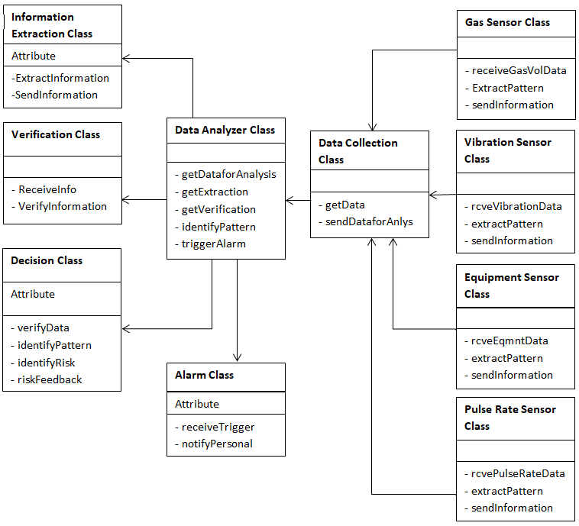

Figure 7

### Dynamic Model

Abnormal Operation:

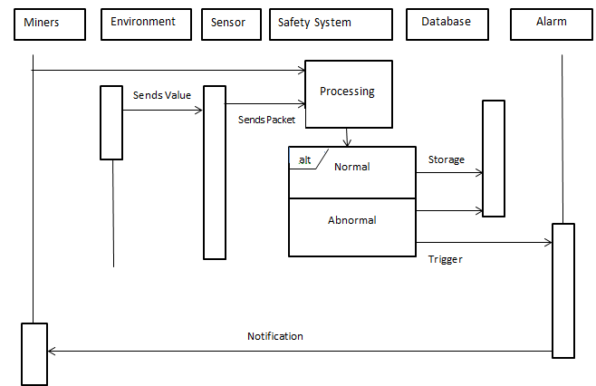

Figure 8

Normal Operation:

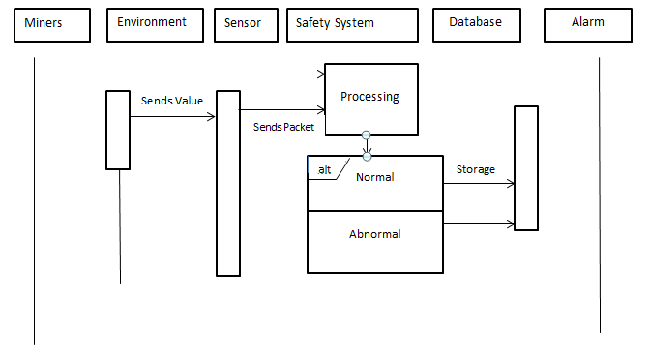

Figure 9

### Subsystem Decomposition

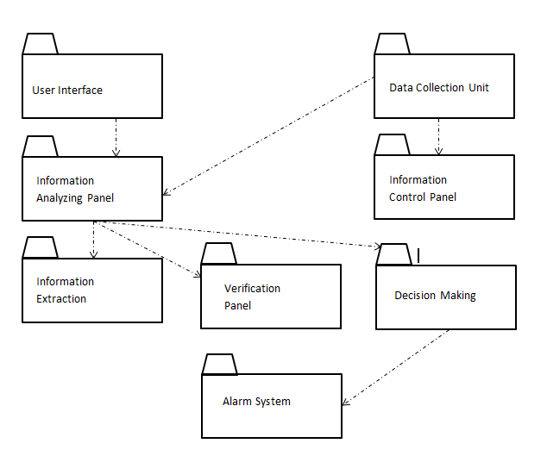

Figure 10

### Hardware / software mapping

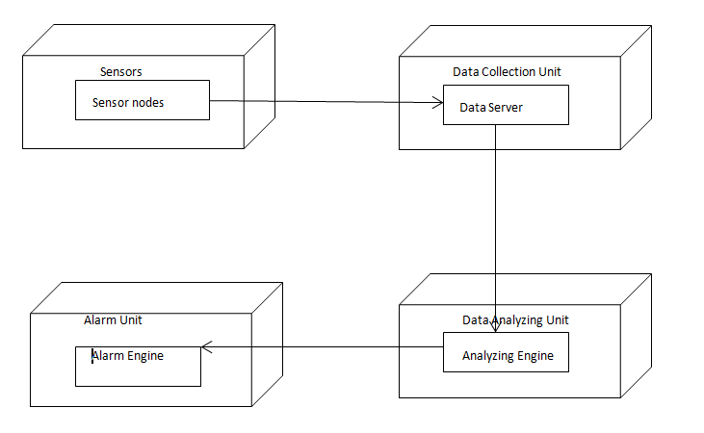

Figure 11

### Data Dictionary

1. Customer ID : It will refer to the customers to who are using our product with a unique id.
2. Surface Type : The type of surface where the mining is taking place( for example - sandy area, rocky area, etc)
3. Condition Code : It refer to type of temperature conditions present in the mines.
4. Weather ID : The type of weather conditions outside the mines.
5. Machine ID - Each machine used for mining will have a unique id associated with it.
6. Data Date & Time - The date and time when the data was captured will be stored.
7. Report Date & Time - The date and time when the report was generated.
8. Sensor ID - Each sensor will have a unique id.
9. GPS ID - Each gps device will also id.
10. Heart Rate Monitor ID(HRM ID) - Heart rate monitors used by the miners will have unique id too.
11. Location Code - A mine will be divided into many sub-areas to identify easily where a miner is currently present in the mine and can easily be tracked.
12. Exit ID - There will be multiple exits each having a unique id and will be used in case of any emergency.

### Persistent Data management

The data from the sensors will be persistent and stored in excel sheets which will be then stored in the cloud which is connected to internet. The user will only have read access to the files so that nobody can edit or delete it. These data may also help our team when any failure occurs to find the time when the sensor failed. The user can see his previous data at any point of time provided he is connected to internet. The data for individual customers will be stored in their own space in cloud with different folders for different months.

There are going to be some data in the code also which needs to be persistent. The threshold for all the sensors are going to be persistent. We won’t allow anyone to modify it. These values we are going to write in a database constant table which will contain all the constant values that can’t be edited and can be used from database.

### Access control and security

The access to the application is only provided to two system at a time. Suppose there are two systems running the application and a third person tries to open the application in a different system. Since there are three multiple sessions running together in parallel, we won’t allow the third person to login and instead redirect him to the application’s homepage(login screen).

If someone who has not logged in to application before, and tries to hack into the application of a customer, we ask the permission from the owner of application(customer) either by sending a sms code to the owner or by sending verification code through email.

The data that the system receives from sensor will be encrypted and when it reaches the system where the application is installed, there it will be decrypted. This will make sure that the data that is being received is secured from external threats.

### Global software control

The application once installed can be used anywhere globally, provided web access is available. The data can be received from the sensors and stored in a black-box from where it will be sent through wifi to the system where application is installed and the data will also be stored in cloud. This does not restrict the person who is monitoring the data to be physically present in the mine.

Also if some problem occurs with any sensor due to which incorrect data is received, and to lodge its complaint if the customer calls our customer service team, then our team may navigate the real time data to find if the issue is with the software or the hardware(sensors).

### Boundary conditions

The power may go off during mining, but all the sensors, gps systems and heart rate monitors will continue to work as they have their own individual battery backup. These sensors though will work on electricity, but they have battery which keeps on charging through electricity. As the power goes off, they will start using their battery without interference.

During mining the sensors and other equipments may get dirty and may dysfunction, but the data will immediately show that there is some flaw from that device and it can immediately be replaced.

Also the sensor positioning in mine is very important. During initial setup of our system, a 3-dimensional map of entire mining area has to be made so that the sensors can be put at the best positions by using least sensors ensuring the entire mine area is covered. There are various software explicitly for creating 3D map of mines like Maptek’s Vulcan software which can downloaded from their website. So as the mine area will grow, the map will also grow.

## Subsystem services

The product will be divided into many subsystems according to their features which will be decided by the type of sensor used. For example, smoke detection subsystem, vibration sensing subsystem, instrumentation failure subsystem, report generation subsystem, etc.

The main output through all the subsystems will be the alarm that would be raised either in form of notifications at the base station or to the miners through alarms blaring. Every feature of the product requires different sensors to monitor the data which is to be sensed.

We can say that every subsystem, in general, has a specific sensor of some specification which would sense data and send to the central system, which would be connected to an alarm in the region of the sensor, for emergency cases.

Another subsystem, which can be classified differently from the above specified category is the report generation subsystem, which would take all the data from the central system and generate reports of the data, accidents, accident-prone areas in the mine, etc.

## User Interface

Currently, this is our vision for the user interface of the project. The UI will feature a sensor reading area which is displayed on the right of the image below. It will show graphs, charts, and information regarding each sensor reading and visualize it properly. Each graph will have a line indicating where the danger level threshold is and will highlight any entries which go beyond that. This is illustrated in the pulse rate reading below.

The UI will also feature a real time map of the locations of all the miners as well as filters to determine which locations of sensors and which types of sensors the user wants to see the location of. In case of any danger, both the data visualization area and the map is highlighted with a warning or an alert to alert the supervisor that something has gone wrong.

Additionally, our UI will feature multiple tabs which have different features. Our Home screen button will lead the user to the beginning of the application where they can select a specific mine location to look at. The Reports section will provide any report generation tools as described in the requirements and allow the user to easily create a report with a time range period. The Data Explorer will allow users to analyze previous data graphs from different months in case they want to look for alarming or interesting behavior or just show the mining inspector the readings of the mine. The Safety Monitor Tab is picture below which shows the main functionality of our software. Next, is the Incident Reports which allow the supervisor to file any incidents which occur quickly and be added to the data system. Finally, there is the Help tab which provides proper documentation and a manual as well as contact information for our support team in case anything is unclear or needs to be double checked.

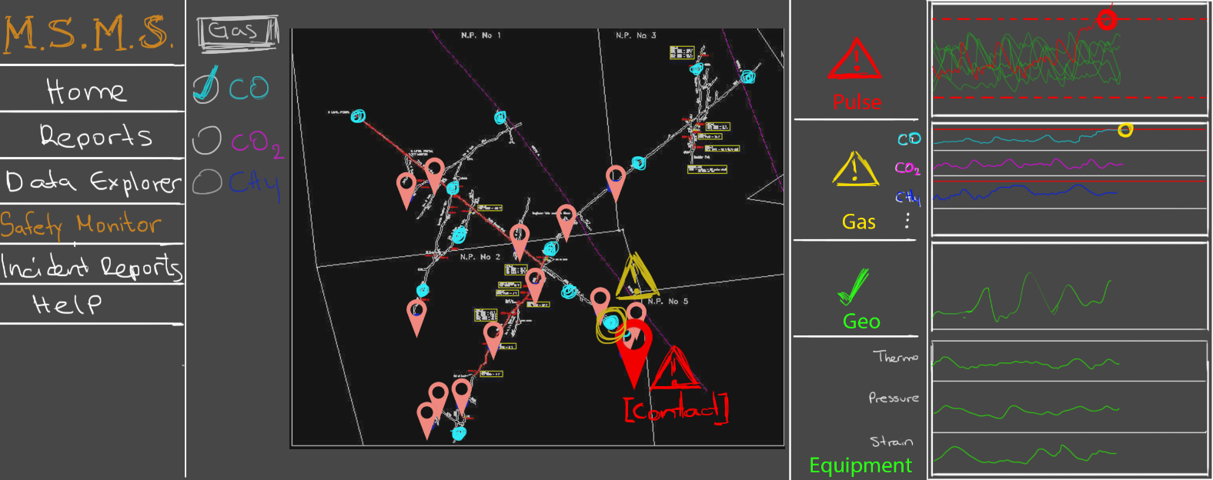

Figure 12

## Object Design

### Object Design trade-offs

The priority of the product is safety and no features which work towards safety features can be compromised. The product design is minimalistic as a whole consisting of sensors, alarms and central system for accepting and analysis of data.

Hence, the product design should not have any trade-offs in reliability, maintainability and availability. At the most, the report generation can be traded-off in terms of maintainability and availability, but not in terms of reliability.

### Interface Documentation guidelines

The product doesn’t have a lot of UI involved in its design. The sensors sense and send data to the central system. The central system might have a UI for showing the locations of all the sensors. It should importantly show the location of the mine which is under danger in case of an alarm going off in that location. The interface should also have an option of displaying reports of all the data that has been collected and generated.

### Packages

The packages used mostly for controlling I/O ports of the sensors would be used in the project like *jdk.dio* which give access to multiple functionalities like *jdk.dio.adc*, *jdk.dio.counter*, *jdk.dio.dac*, *jdk.dio.uart*, etc.

Connection between sensors, alarms and central system could be done wirelessly through TCP sockets.

### Class Interfaces

Class interfaces would be used for setting up wireless communication standards between the components in the system.

Some examples of the class interfaces that would be used are *java.nio.channels,* *java.nio.channels.spi, java.net.HttpURLConnection, java.io.*

# Test Plans

## Features to be tested / not to be tested

The product will run in a hazardous environment which could call on for accuracy at all times. A minor failure in the system might lead to catastrophic results. It is hence, paramount for all the features like sensors and alarms to be tested on a regular basis such that they run efficiently at all times. Moreover, the connecting system at the base station which acts as a central unit for the entire product should be working properly and receiving data from the sensors at real time.

The only feature which does not require to be tested is the report generation part which would require no special testing assuming that the data received would be tested already and is processed accurately.

## Pass/Fail Criteria

* The data collected from sensors should be incomplete or corrupt. The completeness of data is paramount to product success. If the data failure exceeds more than 1%, the sensors is considered as failure.
* The information collected from data must be verifiable, if that is not the case then the data must be considered as corrupt.
* The trigger to alarm system must result in a notification process through which all party is notified, if someone is left out, it will be considered as failure.
* The pulse rate from miners should be verifiable in real time, if there is any disruptions in the signal then then it will be considred as failure.
* If an authorized user not able to use the service then it will be considered as a failure criteria.
* If a trigger to alarm is sent out in a normal working condition, then it will be considered as system failure.
* If the system fails to identify a rise in toxic gas beyond permissible limit, or an equipment failure due to rise in stress or structure failure even after the geo sensors reported this to system, it will be considred a system failure.

## Approach

The testing of all the important features like sensors and alarms for testing their connectivity to the main system would be automatic and should be done at the base station. Every sensor and alarm component will respond with an ‘ACK’ signal on sending a signal.

Sensors will be tested regularly via calibration checks. That is the sensors will be exposed to a known amount of ___ (whatever they are testing) and then measure the reading. If the reading corresponds to the known values, then they work properly.

## Suspension and resumption

Failure of sensors will lead to suspension of testing.

If system fails to extract useful information from data for its analyzation, it will result in suspension of testing.

If system fails to identify pattern from information fed to it, this will be an exit criteria.

If system resumes its normal operation, this will be considered as resumption.

## Testing materials ( hardware / software requirements )

Testing Sensors (Hardware): Sensors will be tested regularly via calibration checks. That is the sensors will be exposed to a known amount of ___ (whatever they are testing) and then measure the reading. If the reading corresponds to the known values, then they work properly.

Testing Radio Communication: Radio communication can be tested in real time by having people communicate and test for delays. This can be done by synching watches or other means and communicating the time to the other user. If the user receives it within seconds (or less), then everything is working correctly.

Automatic Ventilation: The system should trigger automatic ventilation when a certain gas level has reached a threshold. This can be tested by analyzing the readings of the sensors and confirming whether the ventilation does indeed turn on.

Alarm Triggers: The automatic alarm triggers when certain conditions are detected. To check if this feature works, the conditions which would cause the alarm to triggers can be simulated via software values or other means and checking how the system responds.

## Test cases

|  |
| --- |
| **Testcase#:** 1  **Test Title:** Functioning of ground level/surface vibration detection sensor  **Description:** The ground level/surface vibration detector should gives correct output.  **Precondition:** The mining activities are going on in a zone which is prone to structure failure.  **Assumption:** A high amount of vibrations takes place due to blasting in mine.  **Test Steps:**   1. User logins to our application. 2. Check for vibration level immediately after mine blast. 3. Compare the vibration level to pre blast level of vibration. 4. The vibrations data should show an unusual rise in data.   **Expected Result**:The machine should stop running. |

|  |
| --- |
| **Testcase#:** 2  **Test Title:** Functioning of gas detector sensor.  **Description:** The gas detector should sense the rise in level of methane, etc gases.  **Precondition:** The user is logged in our application.  **Assumption:** The mining activity is releasing a lot of toxic gas.  **Test Steps:**  User logins to the system.  Check individual gas sensor.Check for any sudden rise in gas data and if it crosses threshold.  **Expected Result**:The machine should stop running. |

|  |
| --- |
| **Testcase#:** 3  **Test Title:** Functioning of equipment sensors.  **Description:** System must issue an alert if an equipment sensor signs of failure or worn out material.  **Precondition:** Involvement of heavy equipment.  **Assumption:** Mining equipment is under lot of stress.  **Test Steps:**   1. Evaluation of mining equipment sensor output. 2. Verify if the rise in stress level reported by the system or not. 3. If system fails to report abnormal rise in the stress, count it as failure.   **Expected Result**:System should report abnormal rise in the stress level. |

|  |
| --- |
| **Testcase#:** 4  **Test Title:**  Functioning of pulse rate monitor.  **Description:** The product must issue an alert if an abnormal pulse rate is detected from the pulse rate monitors which each mine worker wears.  **Precondition:** The application is in running state.  **Assumption:** One of the worker is not well and his pulse rate is going low.  **Test Steps:**   1. The pulse rate data show one miner pulse rate to be abnormal. 2. The data because of it also shows a low level in that person’s pulse rate reading.   **Expected Result**:The person should stop working as he is in danger. |

|  |
| --- |
| **Testcase#:** 5  **Test Title:**   Functioning of GPS system.  **Description:** System must be aware of miners and sensors location by using the GPS system.  **Precondition:** Miners location is needed for rescue and search operation and system must ensure that all the mining areas are catered by sensors.  **Assumption:** Underground miners are under lot of danger and may sometime require search and rescue operation.  **Test Steps:**   1. Miner geotags a test object at sensor location underground in mines. 2. The location of miner, sensor as recorded by the system is compared to geo tagged location of test object. 3. If the location of miner, sensor and geo tag is found to be similar, then the GPS of system passes the test, otherwise it's a failure.   **Expected Result**: System should be aware of the location of miners and sensors. |

|  |
| --- |
| **Testcase#:** 6  **Test Title:**  Data display.  **Description:** The product must analyze data and display it in a visually friendly format from sensors and alert if a fault or discrepancy is seen from the normal patterns.  **Precondition:** The application is in running state.  **Assumption:** Due to one of the failures like increase in methane level, there is abnormality in data..  **Test Steps:**   1. There is a high level of methane in mine. 2. The pulse rate data shows a low level for that particular person’s pulse rate reading.   **Expected Result**:The data displayed will show a consistent pattern with the readings received from the sensors. Irregular patterns will diverge from the norm so that it is easily recognized. |

|  |
| --- |
| **Testcase#:** 7  **Test Title:**  Display of locations of miners and sensors.  **Description:** The product must visually display a map of the mine with the locations of all miners and sensors.  **Precondition:** The application is in running state and sensors are installed.  **Assumption:** Miners are wearing the gps locators and the sensors also have them  **Test Steps:**   1. The gps locations shows all the miners at their places. 2. A miner moves from location A to location B in the mine.     **Expected Result**: The GPS location on the visualization shall match with the GPS tracker on each sensor used. |

|  |
| --- |
| **Testcase#:** 8  **Test Title:**  All the remote areas of mines should be covered by sensors.  **Description:** The system must trigger a warning if there is an operational area which is not covered by a sensor.  **Precondition:** The system covers all the mining area.  **Assumption:** The complete mining area needs to be covered by gas sensors.  **Test Steps**   1. There should be a fortnight inspection of mining area. 2. If a considerable amount of area is found to be not under sensors location reach, it will result in test failure. 3. System will notify mine supervisor to scale the system by installing a new sensor.   **Expected Result**: The system should provide complete coverage of mining area. |

|  |
| --- |
| **Testcase#:** 9  **Test Title:** Mine’s ventilation system.  **Description:**  The product must automatically turn on the mine's ventilation in an area if a gas reading has reached a threshold in the said area.  **Precondition:**  Adequate ventilation system is present in mine.  **Assumption:**  A lot of toxic gas has been accumulated in the mine.  **Test Steps**   1. The gases reading increase due to high level of toxic gas. 2. The system recognizes the increase in the level of gases. 3. The system instructs the ventilators to start.   **Expected Result**: The ventilation turns on in the designated area within seconds of the abnormal readings. |

## Testing Schedule

The following schedules will be conducted on a regular basis while to product is being deployed. At the end of the cycle, the user is asked for feedback and review on the project:

|  |  |
| --- | --- |
| **Schedule:** | **Time:** |
| **Software Testing** |  |
| Data Analyzing Algorithms | 1 Week |
| Data Extraction | 1 Week |
| Report Generation | 1 Week |
| Unit Testing | 1 Week |
| **Hardware Testing** |  |
| Sensors | 1 Week |
| Communication | 1 Week |
| Alarm Triggers | 1 Week |
| Acceptance Levels | 1 Week |
| **Other** |  |
| User Review | 1 Week |

# Project Issues

## Open Issues

Currently, we haven’t considered how weather plays effect into our software and whether heavy rain or flooding can break any of our equipment or sensors. We don’t have a ready solution for the problem or know if mines already have a solution for that. If flooding is indeed a problem it might be of concern to attempt and isolate all our sensors or buy waterproof ones. In addition it might be of concern to try and cover the mine entrances in some way. Another issue we haven’t looked into is whether our current system obeys all mine safety regulations or if anything needs to be added / removed. This needs to be looked into ad observed prior to implementing the software.

## Off-the-Shelf Solutions

### Ready-Made Products

The only products out there for mining are currently the ones which are in use and it doesn’t seem that many new ones are being developed as of today. However here are the few mentioned as competing products above which can be bought and combined into one, as well as some extra ones:

* + **Surfer -** Surfer is a full-function 2D and 3D mapping, modeling, and analysis software package. Surfer's sophisticated interpolation engine quickly transforms XYZ data into publication-quality maps.
  + **Reactore** – Reactore solutions addresses the inefficiencies that arise as a result of mining operations using disparate systems and manual process that do not talk to each other. The software solution effectively manages the mission critical aspects of mining operation and integrates seamlessly with existing expert systems. This cohesiveness facilitates a 360 degree view of all operations with real-time data 3D dashboards, mine specific business intelligence, powerful analytics and customised reporting.
  + **MSA** – MSA is a safety company which creates safety products for workers protection.  It has created over thousands of safety products. One of the types of product it has created for mining safety is multigas detector.
  + **Komatsu –** Komatsu is a Japanese company and is second after US company Caterpillar in production of construction equipment. Recently it is working on a diagnostic project where it realizes prediction of unexpected failures using equipment’s sensor signals emitted in field of mining. This is the solution provided in collaboration with US based Predictronics and ISID and is called Intelligent Maintenance.
  + **Instantel** – It is a global leader in with best-in-class vibration, noise and air overpressure equipment for quarries, mining, construction, civil, geotechnical and other applications. Some of its products used in mining are:
  + **SKF Copperhead** - It is used for detection of process faults that may cause damage and       affect operation of system. The SKF Copperhead concept uses a specially developed vibration and temperature sensor permanently mounted on the vibrating screen. The sensor is designed to operate in harsh environments and is linked to either a periodic or continuous monitoring system.
  + **Emerson Products** - Emerson produces a list of products which can be used for detecting a lot of toxic gases as well as sense combustibles. Some of the products like Millennium series can detect methane and other poisonous gases.

### Reusable Components

* + Altair 4X Mining Multigas detector – It detects LEL, oxygen, carbon monoxide and hydrogen sulphide.
  + Altairs 5X Multigas detector – It can measure up to 6 gases simultaneously and can detect in LEL and volume percentage range, oxygen, carbon monoxide, carbon dioxide, carbon dioxide, hydrogen sulfide, sulfur dioxide, ammonia, chlorine, VOCs, and many others depending on sensor configuration.
  + Micromate: Monitoring unit with 4 available channels: three channels for recording vibration on three planes and one channel for air overpressure or noise data.
  + Triaxial Smart Geo: Records ground vibration in three planes: transverse, vertical and longitudinal. Does not have to be leveled when installed.
  + Polar FT7 Heart Rate Monitor – a durable and versatile heart rate monitor which is comfortable and easy to use. It’s ranked as one of the most accurate out there.
  + uGPS Rapid Mapper – an underground tunnel mapping tool which is a decentralized sensor system that provides 3D point cloud acquisition capabilities. It also delivers robust data sets that are accurate, reliable and easy to import into any mine planning software.

### Products That Can Be Copied

Many if not all of these were mentioned in the above parts b and c, and so they will simply be reiterated here.

* uGPS Rapid Mapper - – an underground tunnel mapping tool which is a decentralized sensor system that provides 3D point cloud acquisition capabilities. It also delivers robust data sets that are accurate, reliable and easy to import into any mine planning software.
* Reactore – Reactore solutions addresses the inefficiencies that arise as a result of mining operations using disparate systems and manual process that do not talk to each other. The software solution effectively manages the mission critical aspects of mining operation and integrates seamlessly with existing expert systems. This cohesiveness facilitates a 360 degree view of all operations with real-time data 3D dashboards, mine specific business intelligence, powerful analytics and customised reporting.
* Optimum – Optimum is a product which offers multiple modules to aid with report generation and maximize production and reduce costs. Modules include Critical Process & Equipment Management (CPEM), Trigger Action Response Plan (TARP), Analytics, Reports, and Data Portal. All of these are beneficial to our product as we use them all.

## New Problems

### Effects on the Current Environment

Our project’s intent is to either overhaul and replace the currently existing software in the environment in which mining operations are done, or add on to it. Since the main components we deal with are sensors, and we have a base station which is remote from the operational mine, our project does not affect the environment of the workers to much if at all. All operations are meant to proceed as before and not interfere with the schedules of the workers. The only goal of our project is the evacuation of miners in case a potential hazard may occur, and so the only time we interfere with work would be only in critical situations.

### Effects on the Installed Systems

Our software should not cause any existing conflicts to the existing systems of the mines. In fact, they may even be beneficial as we could possibly re use some of their components in order to install our system on top of theirs. Since we are an alarm system which potentially only introduces new sensors and does most of the data analyzing on the software side, we don’t interfere with any pre-existing systems.

### Potential User Problems

Existing users are only meant to benefit from our software. The only change which might cause some user problems is the introduction of a new system. Since people are prone to not like change, integrating a new system and requiring new training or possibly staff may create some dissatisfied reactions from users, however the overall goal is to ease their jobs and problems.

### Limitations in the Anticipated Implementation Environment That May Inhibit the New Product

There are several problems which may arise with the implementation of our product. First, is the introduction of many new sensors which could prove expensive to the mining company. This may cause them to start budgeting and buy less sensors or equipment or cut staff which may mean that our product won’t function as effectively as intended since it won’t have the sensor coverage it requires. Another issue is that mining is such a robust environment that it’s likely that equipment and gear will break fast. This means that we need to provide durable gear which may not be entirely up to us since we are purchasing/using sensors created by other companies. Another problem with our product is that we are trying to keep everything as wireless as possible so that we don’t interfere with the work and so that everything can be packaged and reused quickly after the mining operation is done. Doing things wirelessly introduces many connectivity issues which might prove hazardous as passing information underground via air is hard.

### Follow-Up Problems

Some follow up problems which are unwanted and nearly impossible to deal with were described above, so they will also be restated here. New ones will also be introduced. As mentioned before, we are trying to keep everything as wireless as possible so that we don’t interfere with the work and so that everything can be packaged and reused quickly after the mining operation is done. Doing things wirelessly introduces many connectivity issues which might prove hazardous as passing information underground via air is hard. Another problem mentioned above is the cost of sensors and that we are not manufacturing our own which means we are fully reliant on other companies to create the proper working gear and make it durable so that we may use it and not have to replace it constantly. Another problem not mentioned earlier is the speed of our system. As the data analyzing algorithms are not implemented as of this stage, and we aren’t really sure what they will be, we don’t know how fast they will operate and how reliable they will be. This means that if the algorithms are too slow, this software may not be able to alert miners in due time which means the tactics of the software will need to change or be scrapped. The efficiency of the algorithms also requires a vast amount of background data which also means we will need a data collection phase of our software before it’s able to work at full force. All of these must be considered before implementing our software.

## Tasks

### Project Planning

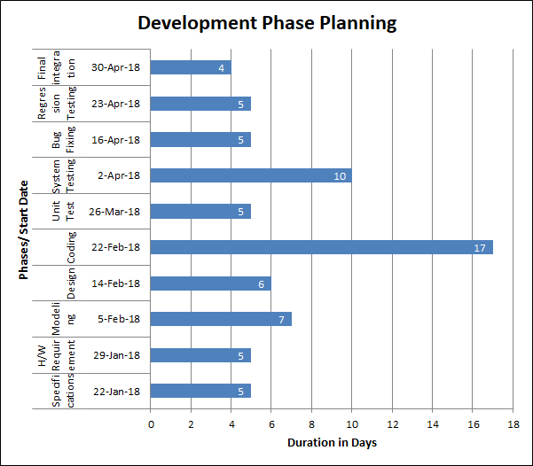

Figure 13

### Planning of the Development Phases

|  |  |  |  |
| --- | --- | --- | --- |
| **Phases** | **Start Date** | **End Date** | **Duration** |
| Specifications | 22-Jan-18 | 26-Jan-18 | 5 |
| H/W Requirement | 29-Jan-18 | 2-Feb-18 | 5 |
| Modeling | 5-Feb-18 | 13-Feb-18 | 7 |
| Design | 14-Feb-18 | 21-Feb-18 | 6 |
| Coding | 22-Feb-18 | 23-Mar-18 | 17 |
| Unit Test | 26-Mar-18 | 30-Mar-18 | 5 |
| System Testing | 2-Apr-18 | 13-Apr-18 | 10 |
| Bug Fixing | 16-Apr-18 | 20-Apr-18 | 5 |
| Regression Testing | 23-Apr-18 | 27-Apr-18 | 5 |
| Final integration | 30-Apr-18 | 3-May-18 | 4 |

## Migration to the New Product

### Requirements for Migration to the New Product

To install the system, our team first needs to inspect the mine area, analyze which all gas sensors needs to be installed, check the depth of mine and accordingly analyze the air-pressure and other conditions on which the heart-rate is dependent, based on all these analysis, the product will be designed. Once the analysis phase is done, the sensors will be installed and then it will be connected to the system. After the implementation phase, testing will take place to check whether correct readings are generated by the sensors.

If a mine was already using some existing sensors to measure toxic gas concentration, equipment failure, surface vibration, we can use their readings to gain information about existing conditions in the mine and then set the threshold of the sensors accordingly.

The product can work with the existing product without interfering its functionality. Once our product is set up, the existing can be removed from the mine without taking a toll on safety of miners.

This new product will require new staff who will be our analysts just for installation purpose but the old staff can continue later once they get trained.

### Data That Has to Be Modified or Translated for the New System

The readings and data generated by the new system is different than the old system. The data generated in the earlier system was just the device reading and had nothing to do with any application and system.

The present data may will be generate and will be put down in excel sheet along with the time at which it was generated. All the data will be in SI units to remove ambiguities. These data will then be stored in cloud for future reference.

## Risks

The wireless connectivity makes the data transmission a little risky. The environment in which the product would be executed under makes it absolutely essential to be accurate. Hence all the risks should be studied and countered accordingly. Some of the example of risks are:

* Connectivity issues
* Inaccurate metrics
* Improper measurement
* Insufficient number of sensors
* Excessive schedule pressure
* Inaccurate cost estimating
* Improper maintenance
* Low quality of sensors
* Improper report generation due to lack of data quality

## Costs

**Equipment Costs (Variable):**

* Gas Sensors (Altair 4x Multigas Detector) - ~$600 each. The number of these sensors varies on the size of the mine, and so the number of these is highly depended on the mine’s scale.
* Polar FT7 Heart Rate Monitor - ~$80 each. The number of these depends on the number of workers present per day. These can be reused if not everyone is use and so we only need the maximum number of these to be the maximum number of mine workers that works at a time (+ extra ones just in case they break)
* FLIR Vibration Meter (or other vibration sensors): ~$1000 each. The number of these may not need to be as high as vibrations in the ground are usually large scale, and so they can be more sparsely laid out.
* Equipment Sensors: ~$500 each. Equipment sensors include all thermos, pressure, and strain sensors. The price of each of them is generally the same, and so depending on the equipment used, different ones may need to be purchased.

**Estimated Work Costs:**

* 20 Requirements
  + We are estimating each requirement to take 1 developer at most 2-3 weeks to implement. Some require more, some require less time, and so we consider this to balance and average out to 2 weeks. We plan on having a team of 4-5 full time developers create this software, and looking at the average salary of a software developer, we estimate 20 requirements split between 5 people to take around 10 weeks, and then incorporating testing weeks in there, the whole project is estimated to take at most 6 months to create. This means that the cost of the project would be $30,000 per developer, and since we have 4-5, this means around $150,000 just to pay their salary.
  + Resource costs such as renting an office space and bills are also estimated to average at about $30,000 for the creation of the project.
  + Hiring a project manager might also be considered useful which means considering the average salary of one, that would be an additional $70,000 for 6 months.
  + Additionally, we plan on having a customer support team available during deployment hours which will cost money annually, and so that cost will not be considered for this.
* Overall, we estimate the project to cost around $300,000 including sensors and development cost of the software.

## Waiting Room

Head up Display was discussed in a length manner but was left out considering the cost factor and the initial design semantics. This idea is parked as of now. The reason it was ruled out was because it would cost too much to implement and the maintenance of it would likely be impossible because of the robust nature of the mining environment. Either too much money would have to be spent on repairing it, or too much on ensuring that it won’t break easily. It also was ruled out because it didn’t provide much additional help to the workers.

## Ideas for Solutions

There has been few ideas we thought while discussing that may be helpful to miners. We thought of adding a HUD(Head-Up Display) helmet and giving it to all miners. This will show them all the alerts like their current heart rate, the temperature of the mine as well as outside temperature. We also thought that HUD may show them safe paths when sensors detect any hazard in the mine. Also this will do the work of a normal helmet which protects head.

Though the HUD helmet is cool and will help in improving the safety of miners, it has many disadvantages too. The product price may rise significantly as more miners will need more HUD display. The maintenance of HUD will also be difficult as in mines a lot of cutting and drilling activities goes on and the helmet may get dirty soon and can break too. This will increase maintenance cost of helmet. The other disadvantage was that the helmet may become heavy which will be be not comfortable to the miners as they have to wear it all the time.

Due to these challenges we dropped the plan of HUD helmet, but in the future if cheap and lightweight HUD will make this idea feasible, but certainly not now.

## Project Retrospective

The project idea was pretty minimalistic but required many ideas to be shot down in order to get to the right one. We had decided to place a box containing all the sensors in strategic locations of the mine. However, we realized that would be inefficient and costly as it would seem logical to place smoke sensors in locations which is highly prone to generate smoke. We were thinking of using data from multiple mines to allocate threshold levels to the sensor data, at first. However, it would have been inappropriate due to the different laws in different countries, and hence, a generalized margin for all the thresholds could not be generated.

In the future, it would be an exciting prospect of collaborating the data collected with deep analytical methodologies like deep learning and neural networks such that they could predict the cause of accident just by the rate and trends of the data rather than the traditional method of the data crossing the threshold.

# Glossary

* MSA – Mine Safety Appliances. A maker of sophisticated safety products that help protect workers who may be exposed to a variety of hazardous conditions.
* Customer ID: It will refer to the customers to who are using our product with a unique id.
* Surface Type : The type of surface where the mining is taking place( for example - sandy area, rocky aea, etc)
* Condition Code: It refer to type of temperature conditions present in the mines.
* Weather ID: The type of weather conditions outside the mines.
* Machine ID - Each machine used for mining will have a unique id associated with it.
* Data Date & Time - The date and time when the data was captured will be stored.
* Report Date & Time - The date and time when the report was generated.
* Sensor ID - Each sensor will have a unique id.
* GPS ID - Each gps device will also id.
* Heart Rate Monitor ID(HRM ID) - Heart rate monitors used by the miners will have unique id too.
* Location Code - A mine will be divided into many sub-areas to identify easily where a miner is currently present in the mine and can easily be tracked.
* Exit ID - There will be multiple exits each having a unique id and will be used in case of any emergency.
* Volume - meter^3
* Tension - Newton/meter
* Concentration - molar/(meter^3)
* Vibrations frequency – hertz
* WSN - Wireless Sensor Network used for capturing the data from sensors

# References / Bibliography

|  |  |
| --- | --- |
| [1] | J. Bell, "Underwater Archaeological Survey Report Template: A Sample Document for Generating Consistent Professional Reports," Underwater Archaeological Society of Chicago, Chicago, 2012. |
| [2] | A. Silberschatz, P. B. Galvin and G. Gagne, Operating System Concepts, Ninth ed., Wiley, 2013. |
| [3] | Robertson and Robertson, Mastering the Requirements Process. |
| [4] | M. Fowler, UML Distilled, Third Edition, Boston: Pearson Education, 2004. |

* NIOSH. Injuries, Illnesses, and Hazardous Exposures in the Mining Industry, 1986–1995:   A Surveillance Report. Washington DC:NIOSH,2000.
* Linet MS, Malker HSR, Chow WH, et al. Occupational risks for cutaneous melanoma among men in Sweden. J Occup Environ Med 1995;37:1127–1135
* ECFR — Code of Federal Regulations, www.ecfr.gov/cgi-bin/text-idx?SID=95a3589813c4b48d6daa8f8df80f0ead&c=ecfr&tpl=%2Fecfrbrowse%2FTitle30%2F30cfrv1_02.tpl.
* IEEE Industry Applications Society 32nd Annual Meeting (Oct. 5-9, 1997; New Orleans, LA), 1997 Oct; :1-7
* US Department of Labor Mine Safety and Health Administration website, cited 13 November 2017. Available at http://www.msha.gov/
* <https://www.gpo.gov/fdsys/pkg/CFR-2015-title30-vol1/pdf/CFR-2015-title30-vol1.pdf>
* <https://en.wikipedia.org/wiki/Mining_accident#21st_century>
* <https://en.wikipedia.org/wiki/Soma_mine_disaster>
* <https://en.wikipedia.org/wiki/Upper_Big_Branch_Mine_disaster>

1. <http://evolution.skf.com/us/fault-detection-for-mining-and-mineral-processing-equipment/>
2. <http://www.predictronics.com/ISID_INTERAFACE_KOMATSU_161101.pdf>
3. <http://vibrationdamage.com/vibration_monitoring.htm>
4. <http://us.msasafety.com/>
5. <http://www.instantel.com/about>
6. <http://www.emerson.com/en-us/automation/measurement-instrumentation/flame-gas-detection/gas-detectors-sensors>

# Index

Design 64, 71

Requirements 49

Test 71, 73, 78